Science 7
Unit E
Lesson 5
Self-Check Quiz

Answer all 5 questions in the spaces provided. Think carefully before typing your answers. If you need help, return to the lesson in the online course. Save your quiz when you are done.

Leave your answers in blue; it will be easier for you and your teacher to see them later.

Question 1

Why does flowing water cause mechanical weathering of rocks at the bottom of a river but rain falling on a rock does not?

Type your answer here.

Question 2

Many hoodoos form with ‘caps’ of rock on top of narrow necks. Explain how this type of hoodoo forms, including why they have caps.

Type your answer here.

Question 3

Explain the most important difference between weathering and erosion.

Type your answer here.

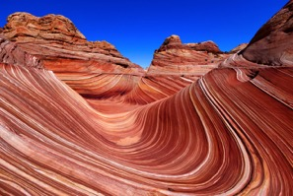
Question 4

The Wave is an amazing sandstone feature found in northern Arizona. It is thought that the Wave was formed by large flooding followed by many years of wind blowing sand particles against the exposed sandstone. Is the Wave an example of weathering, erosion, or both?

Type your answer here.

Question 5

Are fluvial landforms and glacial landforms ever in the same location? Explain your answer.

Type your answer here.

Congratulations! You have completed this self-check quiz.

Now it's time to carefully compare your answers to the suggested answers in the online course. When comparing, you should feel free to make changes to your answers or make extra notes.

Don't forget to save the quiz whenever you make changes.

Keep this quiz for study purposes. If you want more feedback, share it with your teacher.

