Science 7
Unit E
Section 1
Self-Check Quiz

Answer all 5 questions in the spaces provided. Think carefully before typing your answers. If you need help, return to the lesson in the online course. Save your quiz when you are done.

Leave your answers in blue; it will be easier for you and your teacher to see them later.

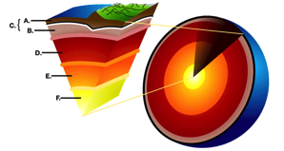
Question 1

Provide names for the six layers of Earth as shown in the diagram below. Which of these layers is the deepest humans have ever drilled?

Type your answer here.

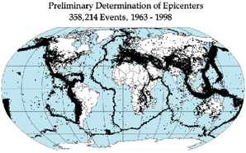
Question 2

This map shows the epicentres of earthquakes that occurred between 1963 and 1998. Why do these earthquakes seem to follow a pattern and why are they not scattered randomly over Earth’s crust?

Type your answer here.

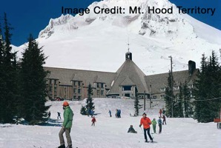
Question 3

Timberline Lodge is a ski lodge on the slopes of Mount Hood, a stratovolcano in Oregon. Timberline is the only place in North America where people can ski every day of the year, including the hottest months of the summer!

What are three questions a cautious person might ask a local geologist before buying a lift ticket to ski at Mount Hood?

Type your answer here.

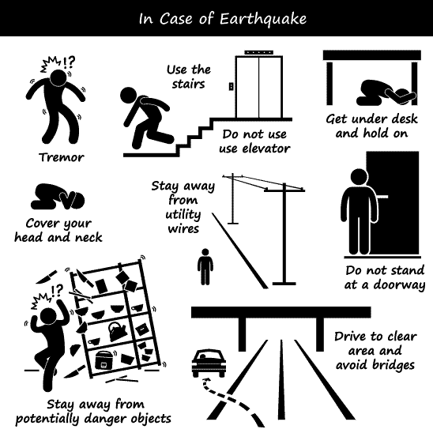
Question 4

The safety poster shown is for people living in locations that experience dangerous earthquakes. The image in the top left corner seems to show that a person feels a tremor and then has time to find safety.

How do people in an earthquake have time to find safety after they feel the first tremors?

Type your answer here.

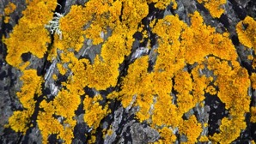
Question 5

The photo shows lichen on a rock on a sunny hillside in Banff. In what two ways is this rock being mechanically weathered?

Type your answer here.

Congratulations! You have completed this self-check quiz.

Now it's time to carefully compare your answers to the suggested answers in the online course. When comparing, you should feel free to make changes to your answers or make extra notes.

Don't forget to save the quiz whenever you make changes.

Keep this quiz for study purposes. If you want more feedback, share it with your teacher.

