Science 7
Unit E, Section 1
Project
Natural Beauty / Natural Disaster

You are required to submit this project to your teacher for marks. Very carefully, read the project task and how to do it. Read the rubric, which explains the expectations for this project.

Project Task

Choose a specific location that could be described as a natural beauty, or a natural disaster, or both. This location should fit into what we studied in this section; a part of Earth’s structure, earthquakes, volcanoes, landslides, weathering, erosion, or deposition. Your location should have a name, or you should be able to take a photo of it to show your teacher.
Describe the location you have chosen using the vocabulary and processes you have learned about in this section. Example of good choices would be the volcano Mount Fuji, the San Andreas Fault in California, or Big Rock in Okotoks.

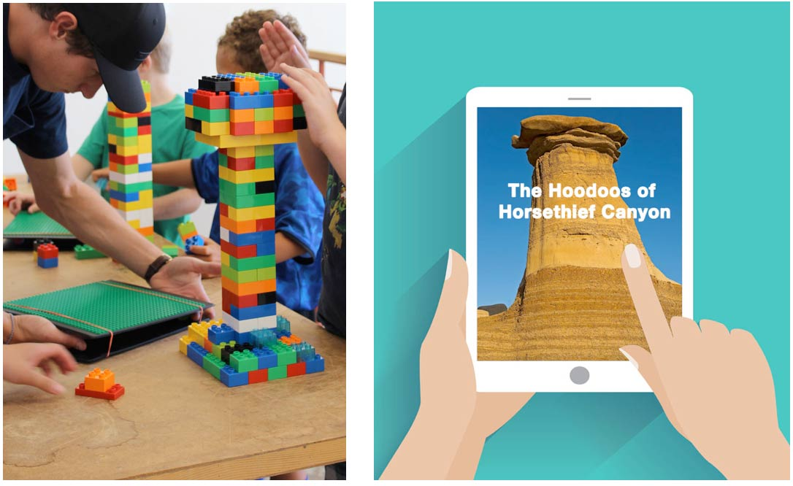

Before starting your project, ask yourself this question:
“How can I describe the location I have chosen using as many descriptive terms and processes as possible from section 1 of this unit?”
Method

You can choose the way that you would like to communicate your location. Here are some ideas that you can pick from:

- Build a model. Photograph or video your model to share with your teacher.
- Use photographs or video. You should use multiple photos or videos to show the various aspects of your location’s characteristics in a multimedia presentation.
- Build a structure in Minecraft and take screenshots that you label or describe.
- Write a detailed description or story about your location.
- Any other creative ideas you have, but check with your teacher first!

Requirements

You must clearly communicate the following information about your location. You can provide written answers to these questions, or you can include the answers as labels if you decide to do a drawing of your design.

Another option is to address these questions by recording yourself (and your model/drawings) on video, or make an audio recording. Just be sure to describe your location very clearly.

- What is the name of your location? Where is it found?
- How does your location represent either sudden change or slow-and-steady change?
- What are some relevant facts, like those that you learned in this section, about your location that illustrates the type of changes it represents to Earth?
- Has your location always been this way? What is the history of your location and its changes to Earth?

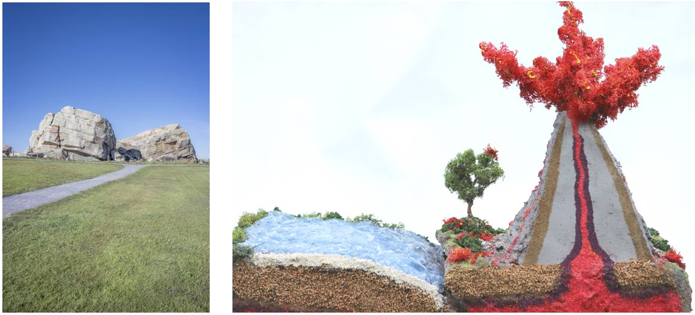

Rubric

This rubric explains how your project will be marked. It explains everything you must include in your project. Read it very carefully before you start your project.

Natural Beauty / Natural Disaster
20 marks
CRITERIA | PERFORMANCE
CRITERIA |  | NOT OK | OK | GOOD | EXCELLENT
CRITERIA | Not Submitted  0 marks | Does not meet criteria  1 mark | Minimally meets criteria  2 marks | Fully meets criteria  3 marks | Exceeds criteria  4 marks
Name and location identified | Not  Submitted | No name and location. Lack of detail. | No specific name and poor location description. Lack of detail. | Name and a general description of location. | Detailed name and a specific description of location.
Type of change to Earth | Not  Submitted | No mention of type of change or supporting evidence. Lack of detail. | Type of change given but no supporting evidence. Lack of detail. | Type of change given with some supporting details for evidence. | Type of change named and explained. Many supporting details.
Supporting evidence relating to this section | Not  Submitted | No supporting evidence. | Supporting evidence lacking. Evidence does not relate to terms and processes from this section. | Some supporting evidence that relates to this section of the course. | Excellent supporting evidence that relates to this section of the course.
History of change in this location | Not  Submitted | No history identified | Some history identified, but does not relate to changes to Earth. | Some examples of history of change mentioned. May include references to future. | Complete history of change given. May include references to future.
Creativity | Not  Submitted | Presentation is very simple and lacks imagination. | Presentation is very simple but shows some imagination. | Presentation shows some creativity and imagination. | Presentation shows a great deal of creativity and imagination.

Submitting Your Work

If you do this project as pencil drawing(s) on another piece of paper, you will have to scan your work to submit it.

If you have prepared any other electronic images or documents for this project, you will need to submit them. The same goes for any Internet location where your work is located, you will need to submit the URL so your teacher can view your work.

When you are ready to submit your completed project, return to the project page in your online course and click the “Add submission” button at the bottom of the page and follow the directions.

Note that when you submit anything to your teacher, PLEASE INCLUDE YOUR NAME IN THE DOCUMENT TITLE. For example, you might title it something like this:

UniE_section1project_Jenny_Smith.doc

