Science 7
Unit E
Section 2
Self-Check Quiz

Answer all 5 questions in the spaces provided. Think carefully before typing your answers. If you need help, return to the lesson in the online course. Save your quiz when you are done.

Leave your answers in blue; it will be easier for you and your teacher to see them later.

Use this table of mineral properties to answer Questions 1 and 2.

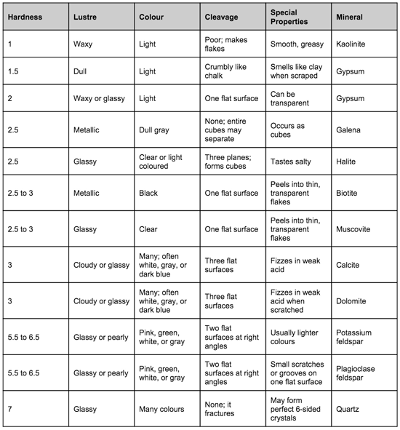

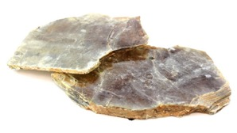
Question 1

An unknown mineral, shown here, has a glassy lustre, a hardness of about 2.5, and cleavage in one plane. Which mineral do you think this is? What one additional test would you do to confirm your prediction, and what should the result of that test be?

Type your answer here.

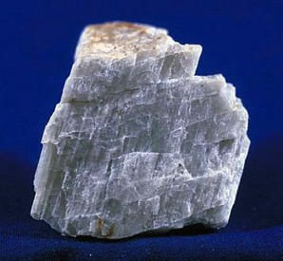
Question 2

An unknown mineral, shown here, has a hardness of 6, cleavage in two flat surfaces, and a glassy lustre. Which mineral do you think this is? What one additional test would you do to confirm your prediction, and what should the result of that test be?
Type your answer here.

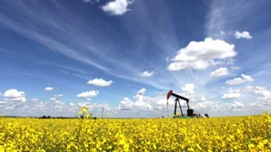
Question 3

What are the four main types of fossil fuels found in Alberta? How are fossil fuels related to rocks and minerals? Where does the name “fossil fuels” come from?

Type your answer here.

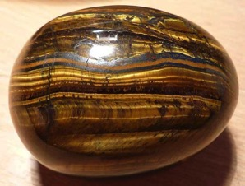
Question 4

While on vacation in southern Alberta, you find an interesting rock specimen along the banks of a stream that flows into a lake.

What observations would help you to decide what this unknown find is?

Type your answer here.

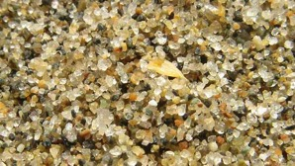
Question 5

Imagine you are a grain of sand. Describe your journey as you travel through the rock cycle.

Type your answer here.

Congratulations! You have completed this self-check quiz.

Now it's time to carefully compare your answers to the suggested answers in the online course. When comparing, you should feel free to make changes to your answers or make extra notes.

Don't forget to save the quiz whenever you make changes.

Keep this quiz for study purposes. If you want more feedback, share it with your teacher.

