Science 7
Unit E, Section 2
Project
Rock Cycle Comic

You are required to submit this project to your teacher for marks. Very carefully, read the project task and how to do it. Be sure to read the rubric, which explains the expectations for this project.

Project Task

The rock cycle describes rocks and the changes they go through. Usually the changes are very slow, but sometimes they are quick and violent. Rocks make up our world, and each rock has a story. Wouldn’t it be interesting to hear some of those stories?
Create a comic that tells one (or more) of these stories. You might follow a grain of sand as it forms a sedimentary rock and passes through time. Or maybe your story will be about a volcano and all of the igneous, metamorphic, and sedimentary friends that it meets. Maybe your comic will be about a team of superhero rocks with each type having their own special power. Or maybe your rocks will be in a motorcycle gang, each riding a unique ‘rock cycle’. Use your imagination, and have fun!
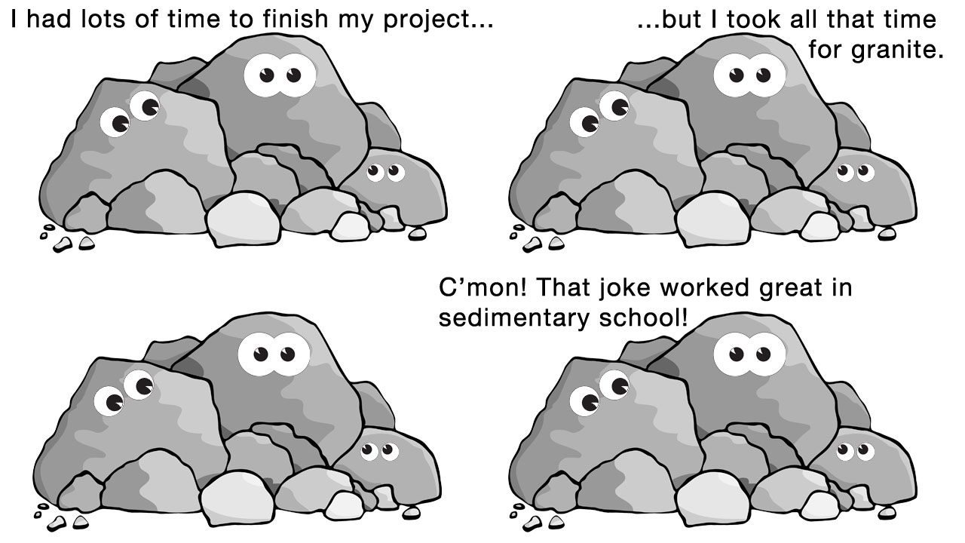

Before starting your project, ask yourself this question:
“How can I describe the changes in the rock cycle using vocabulary from this section in a cartoon?”

Method

There are a number of ways you can create your comic:

- Draw your own. There are many templates available online to draw in. Try searching for comic strip templates. You will need to send a scan or photo to your teacher for marking.

- Create a comic online, or using an app. Just make sure you will be able to save, email, or print your final work to send to your teacher.

  - Apps like “Comics Creator” for a tablet or phone allow you to save and email your work.
  - Games like Minecraft allow you to create a virtual setting for your comic.

- Use a computer program like PowerPoint, Word, Paint, iMovie, or whatever allows you to tell your rock story.

PLEASE check with your teacher before deciding which method to use. Click the following link for some ideas to help you get started:

http://msascienceonline.weebly.com/rock-cycle-comic-strip-project.html

Requirements

Create a comic that tells one (or more) of these stories. You must use the following words and phrases in your comic:

- rock
- mineral
- sedimentary
- sediments
- weathering
- erosion
- deposition
- igneous
- magma
- melting
- metamorphic
- heat
- pressure
Please add any other vocabulary from this section you think will help your comic. You can have fun with the comic, but make sure you use rock cycle words and base some of your plot or action on concepts you learned in this section.

Rubric

This rubric explains how your project will be marked. It explains everything you must include in your project. Read it very carefully before you start your project.

Rock Cycle Comic
16 marks

CRITERIA | PERFORMANCE
CRITERIA |  | NOT OK | OK | GOOD | EXCELLENT
CRITERIA | Not  Submitted  0 marks | Does not meet criteria  1 mark | Minimally meets criteria  2 marks | Fully meets criteria  3 marks | Exceeds criteria  4 marks
Rock cycle processes  mentioned | Not  Submitted | No rock cycle processes mentioned.  No detail | Few rock cycle processes mentioned. Lack of detail. | General descriptions from the rock cycle. | Detailed and specific mention of the rock cycle.
Vocabulary words included | Not  Submitted | Few vocabulary words mentioned. Words used out of context. | Not all vocabulary words used. Poor context. | All vocabulary words used. Context adequate. | All vocabulary words used. Context excellent.
Supporting evidence relating to this section | Not  Submitted | No supporting evidence. | Supporting evidence lacking. Evidence does not relate to terms and processes from this section. | Some supporting evidence that relates to this section of the course. | Excellent supporting evidence that relates to this section of the course.
Creativity | Not  Submitted | Presentation is very simple and lacks imagination. | Presentation is very simple but shows some imagination. | Presentation shows some creativity and imagination. | Presentation shows a great deal of creativity and imagination.

Submitting Your Work

If you do this project as pencil drawing(s) on another piece of paper, you will have to scan your work to submit it.

If you have prepared any other electronic images or documents for this project, you will need to submit them. The same goes for any Internet location where your work is located, you will need to submit the URL so your teacher can view your work.

When you are ready to submit your completed project, return to the project page in your online course and click the “Add submission” button at the bottom of the page and follow the directions.

Note that when you submit anything to your teacher, PLEASE INCLUDE YOUR NAME IN THE DOCUMENT TITLE. For example, you might title it something like this:

UnitE_section2project_Jenny_Smith.doc

