Science 7
Unit E
Lesson 10
Self-Check Quiz

Answer all 5 questions in the spaces provided. Think carefully before typing your answers. If you need help, return to the lesson in the online course. Save your quiz when you are done.

Leave your answers in blue; it will be easier for you and your teacher to see them later.

Question 1

The idea of continental drift occurred to early scientists as soon as maps of the Atlantic coasts of South America and Africa were drawn accurately. Why had nobody thought of continental drift until that time?

Type your answer here.

Question 2

Why was the idea of continental drift, as presented by Alfred Wegener, not accepted by most other scientists until long after Wegener died?

Type your answer here.

Question 3

Evidence used to explain continental drift includes fossil evidence such as the animal Mesosaurus and the plant Glossopteris, both of which are found on several continents that made up Pangaea and Gondwana. However, why have no marsupial fossils such as ancient kangaroos or their ancestors or monotreme fossils such as an ancient duckbill platypus been found on continents other than Australia?

Type your answer here.

Question 4

Many diagrams explaining how the continents and tectonic plates fit together include areas of continental shelf, which are under the ocean.

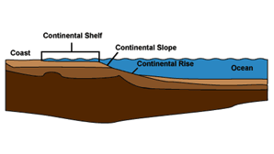
The continental shelf is part of the continent, but it is found underwater.
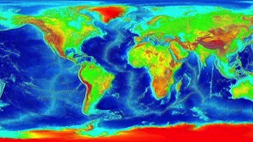
The continental shelf, shown here in light blue, often is found on maps showing continental drift.

Often, these areas are shaded a slightly different colour, but they are still part of the continental crust of the plate they are on. Why might including these areas of continental shelf be important although they are under water at present?

Type your answer here.

Question 5

Geologists believe that another supercontinent will form about 300 million years from now. Will the supercontinent that forms look just like Pangaea? Explain your answer.

Type your answer here.

Congratulations! You have completed this self-check quiz.

Now it's time to carefully compare your answers to the suggested answers in the online course. When comparing, you should feel free to make changes to your answers or make extra notes.

Don't forget to save the quiz whenever you make changes.

Keep this quiz for study purposes. If you want more feedback, share it with your teacher.

