Science 7
Unit E, Lesson 11
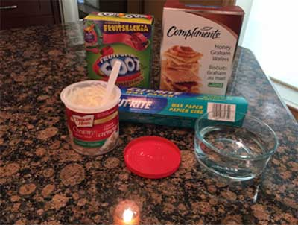
Try It!
Yummy Plate Tectonics

https://adlc.wistia.com/medias/1laue1xzaa

This experiment explores the boundaries formed in plate tectonics. You will use graham wafers, fruit strips and frosting as a model of Earth. Using this model you will simulate diverging, converging, and transform boundaries between tectonic plates.

Materials:

- wax paper
- graham wafers
- fruit strips
- plastic spoon and/or knife
- frosting or whipping cream
- water

Instructions:

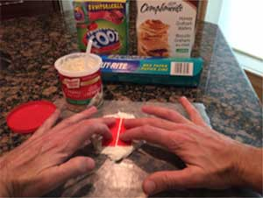
Divergent Boundary
- Place two dollops of frosting on a piece of wax paper. Spread it out a bit to make a thick layer.
- Place two fruit strips side by side on the dollop of frosting. Leave a small gap between the two pieces of fruit strip.
- Gently press down on both fruit strips and slowly move them further apart. Observe what happens.

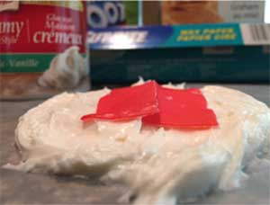
Convergent Boundary: Oceanic-Oceanic
- Gently lift the two fruit strips off of the frosting. Smooth the frosting and place the two fruit strips back on the frosting with a small gap between them.
- Gently push the two fruit strips towards each other. Observe what happens.

Convergent Boundary: Oceanic-Continental
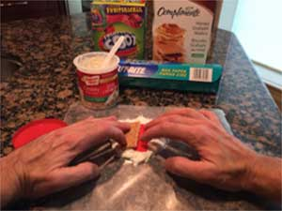
- Gently remove the fruit strips from the frosting. You are finished with the subducted fruit strip (the one that went under the other). Keep the top fruit strip, or get a new strip if necessary.
- Place a fruit strip and a graham wafer on the frosting with a small gap between them. The graham wafer should be sitting higher on the frosting than the fruit strip.
- Gently push the graham wafer towards the fruit strip. Observe what happens.

Convergent Boundary: Continental-Continental
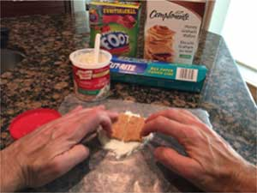
- Remove the fruit strip from the frosting. You do not need the fruit strip anymore. Smooth the frosting and add more if needed.
- Split a graham wafer in half, forming two identical pieces.
- Dip 1 cm of one end of each wafer into a glass of water for 2 seconds.
- Place the two wafer pieces side-by-side on the frosting layer with a small gap between them. Make sure the wet ends are closest together.
- Gently push the wafers together so the wet ends meet. Continue pressing the wafers together gently. Observe what happens.

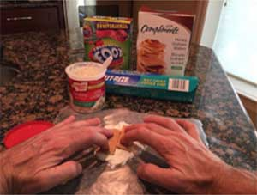
Transform Boundary
- Gently remove the graham wafers from the frosting. You can use them again if they are in good condition. Get two new pieces if they are not. Smooth the frosting and add more if needed.
- Place the two wafer pieces side-by-side on the frosting layer so they look like one large piece. Make sure the ends that are closest together are dry.
- Gently push the wafers past each other in opposite directions while also gently pushing them together. Observe what happens.

Questions:

Think about the following questions very carefully. Then, type answers in the space provided. When you have your answers, click the questions in the online course for feedback.

- What parts of Earth do the frosting, fruit strip, and graham wafers represent in this model? Are these good models, or could they be improved? Explain.

- For the divergent plate boundary model we pressed down on the on the fruit strips as we pulled them apart. What natural process does this represent? How accurate is the model compared to what actually happens? Explain.

Questions continued:

- In two of the convergent boundary models we pushed together two fruit strips, or a fruit strip and a graham wafer. What is the name is given to the area where a fruit strip goes under a graham wafer or another fruit strip? Does this name seem appropriate based on what you saw? Explain.

- In one of the convergent boundary models we had to soak the graham wafer for a few seconds. Why was this necessary?

- In the transform boundary model you pushed two graham wafers past each other. Why would this work better than pushing two fruit strips past each other? Do you think there is a difference between continental-continental transform boundaries and oceanic-oceanic transform boundaries in reality? Explain.

