Science 7
Unit E
Lesson 11
Self-Check Quiz

Answer all 5 questions in the spaces provided. Think carefully before typing your answers. If you need help, return to the lesson in the online course. Save your quiz when you are done.

Leave your answers in blue; it will be easier for you and your teacher to see them later.

Question 1

Continental drift is difficult to explain, as Alfred Wegener discovered. Provide your best explanation of how tectonic plates move around on Earth’s surface. You may use a model or example to help your explanation.

Type your answer here.

Question 2

Geologists measuring the movement of South America and Africa using GPS satellites have determined that these two continental plates are moving apart at a rate of 3.5 cm per year. How many cm per year do you think are being added at the Mid-Atlantic Ridge between these two plates? Explain.

Type your answer here.

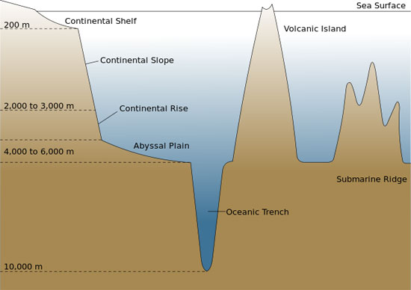
Question 3

The deepest part of any ocean on earth is the Mariana Trench, located off the coast of the Philippines. The ocean is almost 10 km deep in parts of this trench, which is a subduction zone between the Mariana Plate and the Pacific Plate, two oceanic tectonic plates.

Can you explain why the trench is so deep?

Type your answer here.

Question 4

The Queen Charlotte fault is a major transform fault between the Pacific Plate and the North American Plate off the coast of British Columbia and Alaska. Knowing this, would you predict that Alaska has earthquakes? Explain.

Type your answer here.

Question 5

Sometimes Oreo cookies are used as a model to explain tectonic plate boundaries. Choose one type of boundary and suggest the steps that would be used to model this type of boundary with an Oreo cookie.

Type your answer here.

Congratulations! You have completed this self-check quiz.

Now it's time to carefully compare your answers to the suggested answers in the online course. When comparing, you should feel free to make changes to your answers or make extra notes.

Don't forget to save the quiz whenever you make changes.

Keep this quiz for study purposes. If you want more feedback, share it with your teacher.

