Science 7
Unit E, Lesson 12
Try It!
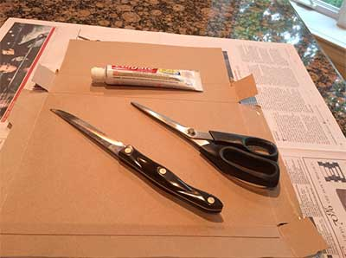
Toothpaste Hot Spot

https://adlc.wistia.com/medias/dm9pskbj09

This experiment explores the formation of a volcanic island chain from the action of a hot spot below Earth’s crust. You will use toothpaste to simulate the rising magma from the hot spot, and cardboard slowly moving over the toothpaste to simulate the motion of a tectonic plate over a mantle plume.

Materials:

- cardboard, such as a cereal box
- scissors
- pointed knife for making holes in the cardboard
- squeezable tube of toothpaste
- a pan or sheet of newspaper to catch any mess

Be very careful with the sharp knife.

Instructions:

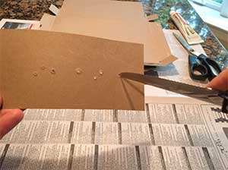
- Cut a strip of cardboard that is easy enough to hold in one hand, about 30 cm x 10 cm.

- Carefully use the knife to make a series of about 8 holes in a rough line along the cardboard. Make some larger than the others, and make some occur in small groups of two or three.

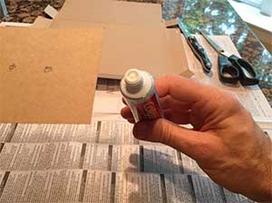
- Remove the cap on the toothpaste and make sure it will freely flow out of the tube when you squeeze.

- Hold the cardboard in one hand and place the toothpaste tube below the first hole in the cardboard. Make sure the pan or sheet of newspaper is underneath to catch any toothpaste mess that falls.

- Gently squeeze the toothpaste until you start to see it emerge from the first hole in the cardboard. Observe what happens.
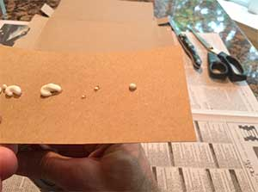
- Continue to gently squeeze the tube with one hand while moving the cardboard so that the toothpaste stops flowing through the first hole and starts flowing through the second hole, or set of holes. Observe what happens.

- Continue slowly moving the cardboard until the toothpaste has flowed through the final hole. Observe what happens.

Questions:

Think about the following questions very carefully. Then, type answers in the spaces provided. When you have your answers, click the questions in the online course for feedback.

- What parts of Earth do the toothpaste, cardboard, holes cut in the cardboard, and squeezed toothpaste tube represent? Are these good models, or could they be improved? Explain.

- The instructions say to move the cardboard over the toothpaste, and not to move the toothpaste under the cardboard. Why is this important in understanding hot spots and the volcanoes they form?

- What differences did you observe between the toothpaste volcanoes that formed over the different holes and collections of holes that you made? How does this compare to the Hawaiian Islands?

- Was there any erosion of your toothpaste islands? Compare your answer to the chain of Hawaiian Islands.

- The cardboard in this activity is thin, and probably represents an oceanic plate like the Pacific Plate that Hawaii is on. If you wanted to re-do this activity simulating a hot spot under a continental plate, such as the Yellowstone hot spot, how might you change the experiment?

