Science 7
Unit E, Lesson 13
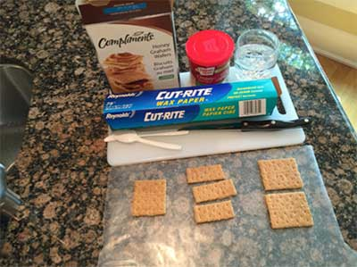
Try It!
Building Sweet Mountains

https://adlc.wistia.com/medias/us0v3p276t

This experiment explores mountain building. You will use graham wafers and frosting as a model of Earth. Using this model you will simulate mountain building, faults, and folds.

Materials:

- wax paper
- graham wafers
- plastic spoon and/or knife
- a knife with a sharp point
- frosting or whipping cream
- water

SAFETY WARNINGS: Be careful with the sharp knife. Do not eat your experiment!

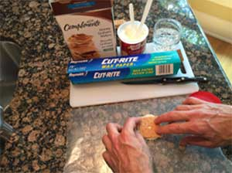
Instructions:

Mountain Building: Volcano

- Use a knife with a sharp point to gently drill a hole in the middle of a graham cracker.
- Place two dollops of frosting on a piece of wax paper. Spread it out a bit to make a thick layer.
- Place the graham wafer on the frosting layer so the hole of the wafer is over the frosting.
- Gently press down on the wafer. Observe what happens.
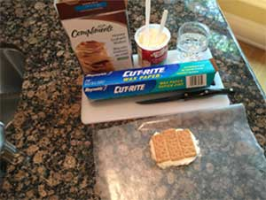
Mountain Building: Fault-Block Mountains

- Break a graham cracker into three equal pieces.
- Place two dollops of frosting on a piece of wax paper. Spread it out a bit to make a thick layer a little larger than one graham cracker.
- Place the three wafer pieces side-by-side on the frosting layer so they look like one large piece.
- Press down on the middle of the three wafer pieces. Observe what happens.

Mountain Building: Fold-and-fault mountains
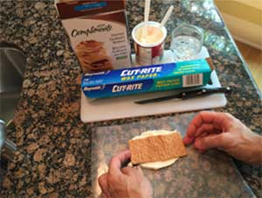
- Break a graham cracker into two equal pieces.
- Place two dollops of frosting on a piece of wax paper. Spread it out a bit to make a thick layer a little larger than one graham cracker.
- Dip 1 cm of one end of each wafer into a glass of water for 2 seconds.
- Place the two wafer pieces side-by-side on the frosting layer so they look like one large piece. Make sure the wet ends are closest together.
- Gently push the wafers together so the wet ends meet. Continue pressing the wafers together gently. Observe what happens.

Questions:

Think about the following questions very carefully. Then, type answers in the spaces provided. When you have your answers, click the questions in the online course for feedback.

- What parts of Earth do the frosting and graham wafers represent in this model? Are these good models, or could they be improved? Explain.

- In the volcano mountain building, we pressed down on the graham wafer. What natural process does this represent? How accurate is the model compared to what actually happens? Explain.

- In the fault-block mountain building, we pressed down on the middle piece of graham wafer. What natural processes does the pressing down represent? How accurate is the model compared to what actually happens? Explain.

- In the fold-and-fault mountain building we had to soak the graham wafer for a few seconds. Why was this necessary? Did you notice folding and faulting in your fold-and-fault mountain building model? Did the folding and faulting occur at the same time, and in the same place? Explain your observations.

