Science 7
Unit E, Section 3
Project
Tectonic Animation

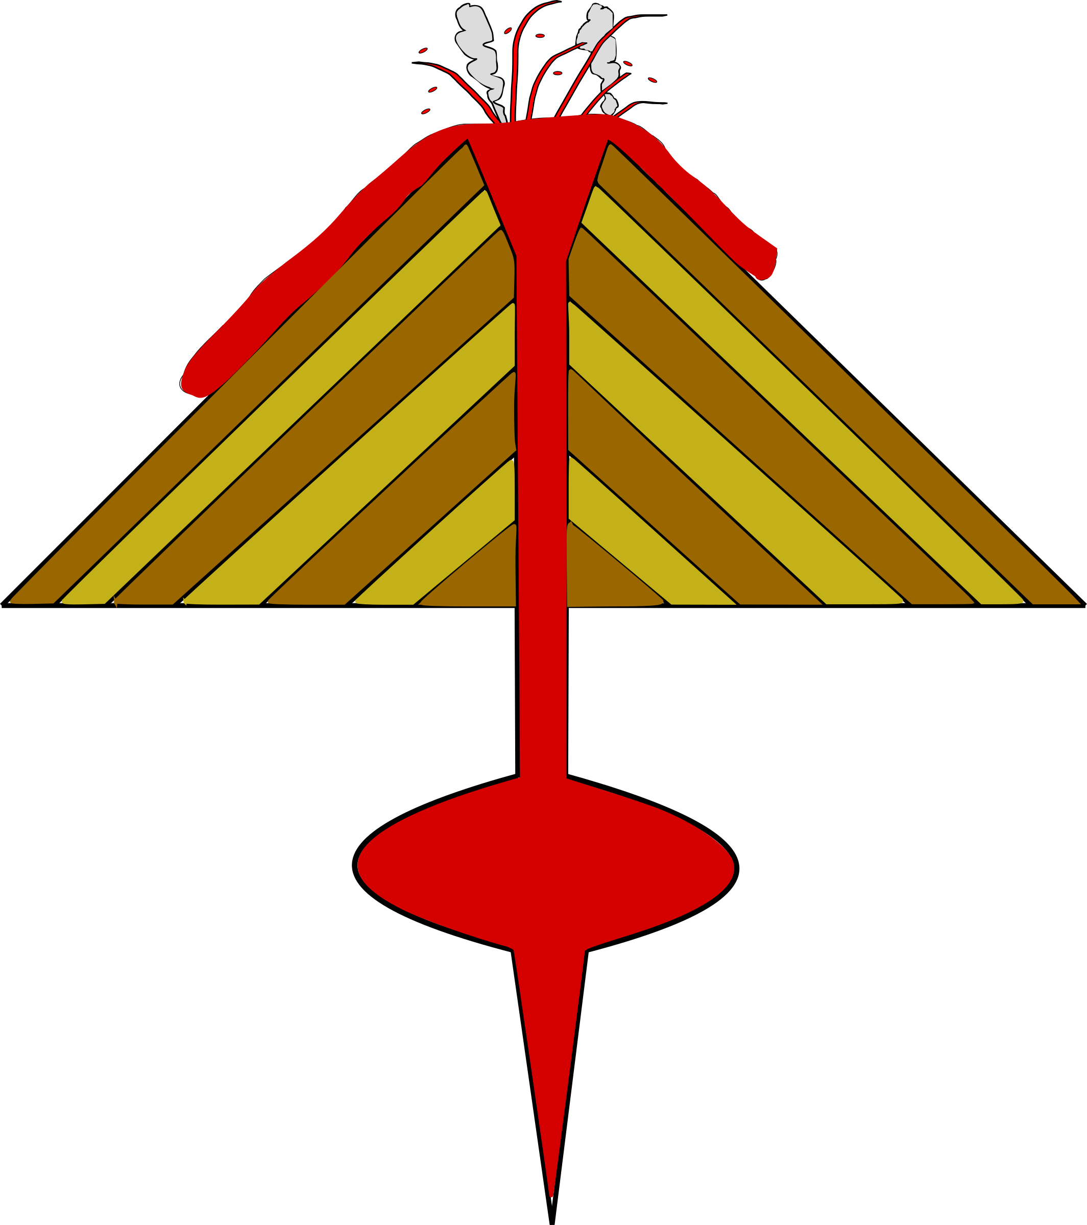
You are required to submit this project to your teacher for marks. Very carefully, read the project task and how to do it. Be sure to read the rubric, which explains the expectations for this project.

Task

Create an animation of a process that you learned about in this section. You might make a flip-book of the break-up of Pangaea, or a claymation of a hot spot island chain being created, or an animated gif of the formation of a continental mountain range, or a stop-motion Lego movie of a mantle plume. Then, in a brief summary, explain how your animation shows an important concept related to an Earth change from this section.

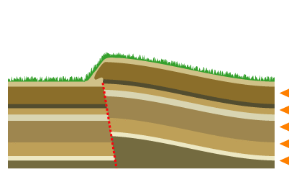
Before starting your project, ask yourself this question: “How can my animation represent a concept related to plate tectonics, and how can I explain my animation using proper vocabulary and labels?”

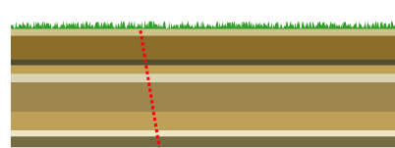

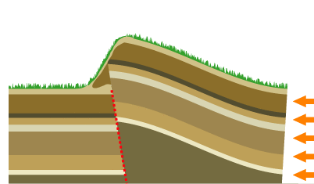
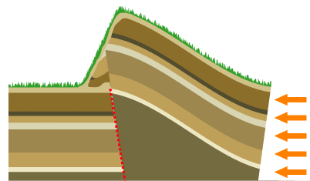

Method

There are a number of ways you can create an animation for this project:

- Create a simple flip-book, or a series of images that would form an animation.

- Create a stop-motion or claymation movie, and an animated gif, using a camera and movie software on your computer.

- Use PowerPoint, Keynote, Wideo, Prezi, or some other software or website to make a creative animation.

PLEASE check with your teacher before deciding which method to use. Remember, whatever method you choose, you will need to get a copy of your work to your teacher for marking.

Requirements

You must create:

- An animation, or series of images, that show one of the processes related to plate tectonics discussed in section 3 of this unit. Your animation must be at least four frames or pictures in length.

- An animation that relates directly to a process in mountain building, plate tectonics, continental drift, or hot spots, or another geology process mentioned in this section.

- A summary of your work, including proper vocabulary and descriptions of the processes you have chosen to animate.

Rubric

This rubric explains how your project will be marked. It explains everything you must include in your project. Read it very carefully before you start your project.

Tectonic Animation
20 marks
CRITERIA | PERFORMANCE
CRITERIA |  | NOT OK | OK | GOOD | EXCELLENT
CRITERIA | Not  Submitted  0 marks | Does not meet criteria  1 mark | Minimally meets criteria  2 marks | Fully meets criteria  3 marks | Exceeds criteria  4 marks
Tectonic animation | Not  Submitted | 1 frame. Not related to content in section. | 2 frames. Poorly related to content in section. | 3 frames. Good relation to content in section. | 4 frames or more. Excellent relation to content in section.
Tectonic processes  in summary | Not  Submitted | No tectonic processes mentioned.  No detail | Few tectonic processes mentioned. Lack of detail. | General descriptions related to plate tectonics from this section. | Detailed and specific mention of plate tectonics from this section.
Tectonic vocabulary words in summary | Not  Submitted | No vocabulary words mentioned. | Few vocabulary words used. Poor context. | Good vocabulary. Context adequate. | Very good vocabulary words used. Context excellent.
Supporting evidence relating to this section | Not  Submitted | No supporting evidence. | Supporting evidence lacking; does not relate to terms and processes from this section. | Some supporting evidence that relates to this section of the course. | Excellent supporting evidence that relates to this section of the course.
Creativity | Not  Submitted | Animation is very simple and lacks imagination. | Animation is very simple but shows some imagination. | Animation shows some creativity and imagination. | Animation shows excellent creativity and imagination.

Submitting Your Work

If you do this project as pencil drawing(s) on another piece of paper, you will have to scan your work to submit it.

If you have prepared any other electronic images or documents for this project, you will need to submit them. The same goes for any Internet location where your work is located, you will need to submit the URL so your teacher can view your work.

When you are ready to submit your completed project, return to the project page in your online course and click the “Add submission” button at the bottom of the page and follow the directions.

Note that when you submit anything to your teacher, PLEASE INCLUDE YOUR NAME IN THE DOCUMENT TITLE. For example, you might title it something like this:

UnitE_section3project_Jenny_Smith.doc

