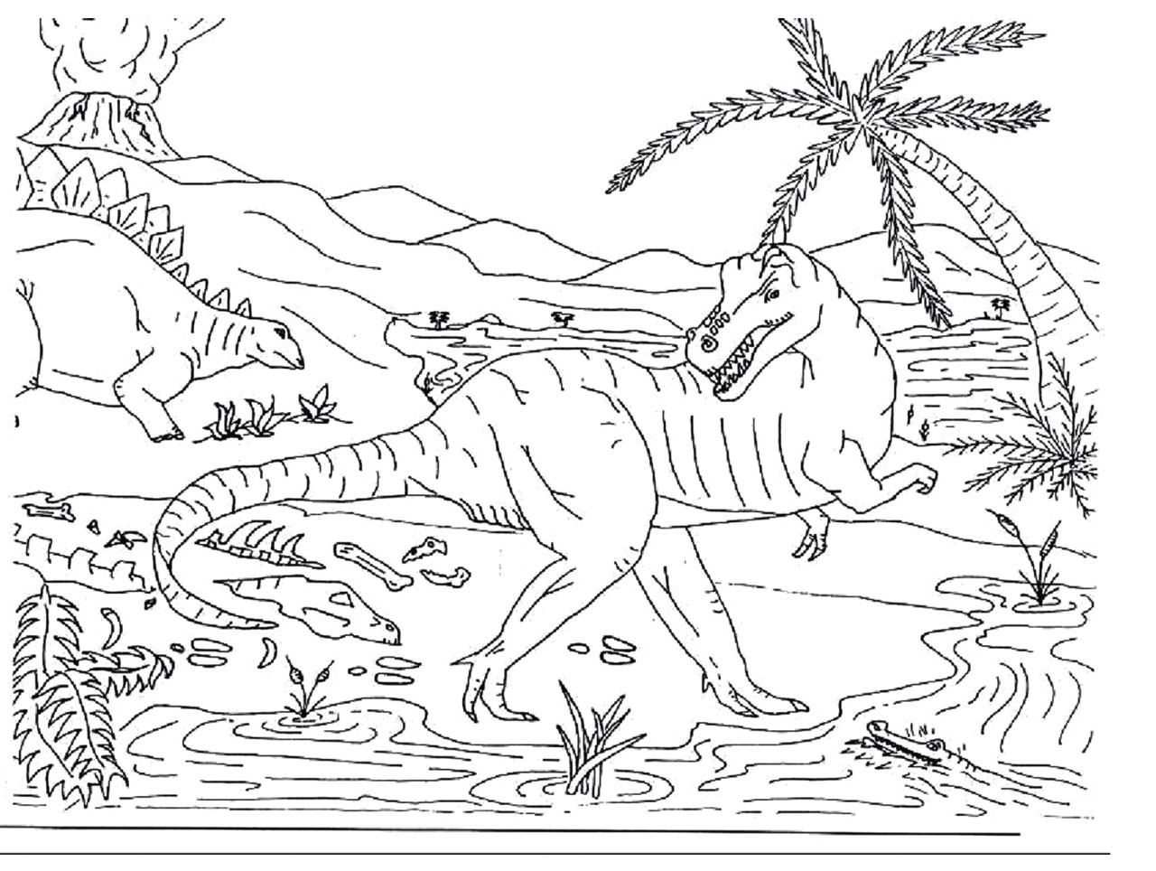
Science 7
Unit E, Section 4
Think • Interpret • Decide
Observations and Inferences

Science is all about making observations and inferences. Observations are things that you can see with own eyes and make note of for later reference. Inferences are the reasons, connections, and explanations that are made based on your observations. Gravity is an excellent example. Things fall to the when you let go of them. This is an observation. Scientists make note of this, and try to make inferences that explain what they saw. The theory of gravity is a very complicated inference for why things fall to the ground.

Earth’s distant past is much more difficult to observe than gravity, and so the challenge becomes even greater to make inferences that explain the observations that we make when we find a fossil, or use radioactive dating to find out how old a rock is, or discover similar fossils on different continents.

Look at the image shown above of an ancient swampland and the organisms that live there. Examine the following statements and place an O if the statement describes and observation, and an I if it describes an inference.

_____ 1. The volcano is erupting.
_____ 2. The camptosaurus is going to eat the stegosaurus.
_____ 3. The stegosaurus will run into the water to escape.
_____ 4. The camptosaurus is leaving tracks in the ground.
_____ 5. The ground where the camptosaurus is walking is wet.
_____ 6. There are plants growing in the water.
_____ 7. The camptosaurus is going into the water to eat the plants.
_____ 8. There is a tree growing next to the river.
_____ 9. The tree looks like a palm tree.
_____ 10. The climate is warm.
_____ 11. The stegosaurus is eating the plant.
_____ 12. The stegosaurus is an herbivore.
_____ 13. There are bones from a dead animal by the shore.
_____ 14. The camptosaurus killed the animal.
_____ 15. Some more bones are in the water.
_____ 16. The camptosaurus can’t swim and will drown.
_____ 17. Lava is flowing down the sides of the volcano.
_____ 18. The camptosaurus has sharp teeth for eating meat.

After you have finished filling in the blanks, ask yourself the following questions;

Think: Do you understand the difference between an observation and an inference?

Interpret: Why is it important to understand the differences between an observation and an inference in science?

Decide: In your view, what are the best types of evidence scientists can hope to find when study the ancient Earth?

Think • Interpret • Decide

Now that you have have thought about the activity, check your answers against those that appear below.

__O__ 1. The volcano is erupting.
__I__ 2. The camptosaurus is going to eat the stegosaurus.
__I__ 3. The stegosaurus will run into the water to escape.
__O__ 4. The camptosaurus is leaving tracks in the ground.
__I__ 5. The ground where the camptosaurus is walking is wet.
__O__ 6. There are plants growing in the water.
__I__ 7. The camptosaurus is going into the water to eat the plants.
__O__ 8. There is a tree growing next to the river.
__O__ 9. The tree looks like a palm tree.
__I__ 10. The climate is warm.
__O__11. The stegosaurus is eating the plant.
__I__12. The stegosaurus is an herbivore.
__O__13. There are bones from a dead animal by the shore.
__I__14. The camptosaurus killed the animal.
__O__15. Some more bones are in the water.
__I__16. The camptosaurus can’t swim and will drown.
__O__17. Lava is flowing down the sides of the volcano.
__O__18. The camptosaurus has sharp teeth for eating meat.

Do the answers match what you decided? If not, don't worry, you will be learning much more about observations and inferences in this section.

