Science 7
Unit E, Lesson 14
Try It!
Homemade Fossils
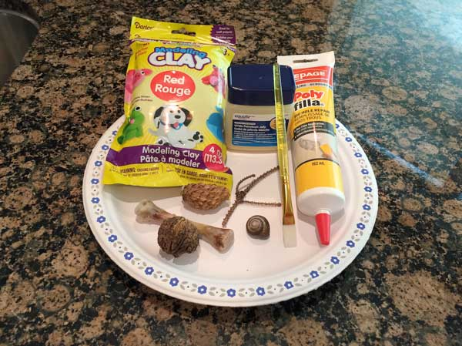
https://adlc.wistia.com/medias/tj34csfv20

Try this simple experiment at home to make your own fossils. It will take at least 24 hours for the final fossils to harden enough to be examined. Be patient!

Materials:

- newspaper
- tupperware container or plate
- clay or dough
- small objects for fossils (shells, leaves, cones, etc)
- petroleum jelly
- small paintbrush
- plaster of paris, repair spackle, or white glue

Instructions:

- Gently press clay into the bottom of a container to form a layer a few centimetres thick.
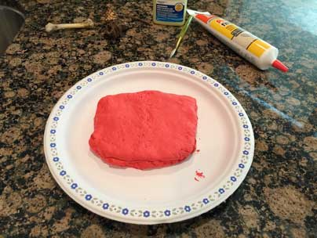
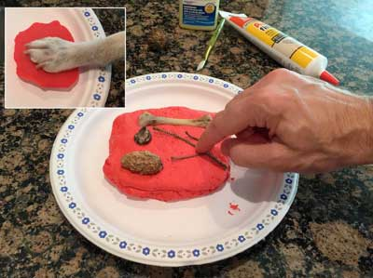
- Use your collection of small objects to make impressions that will become mold, cast, or trace fossils.

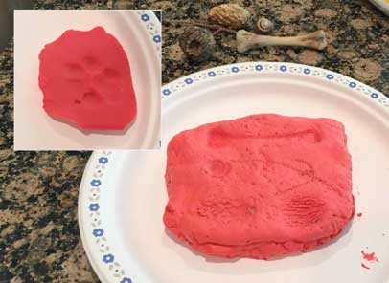
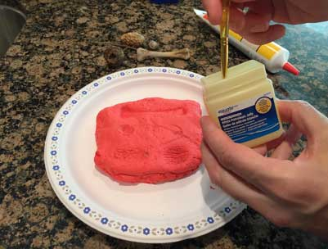
- Use the paintbrush to gently apply a coat of petroleum jelly to the impressions that you will make into cast fossils.

- Add plaster of paris or white glue into the cast fossil impression(s) that has been coated with petroleum jelly.

- Leave the plaster or glue to harden for at least 24 hours; leave for longer than 24 hours if the mold was deep.

- When the plaster or glue is dry and hardened carefully lift the cast of the impression out of the mold.
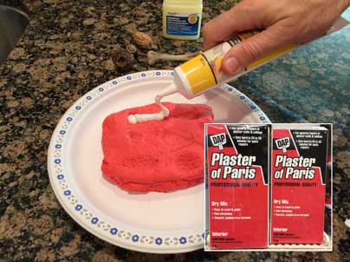
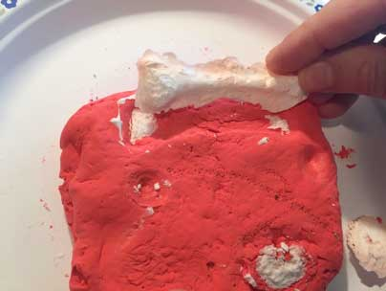
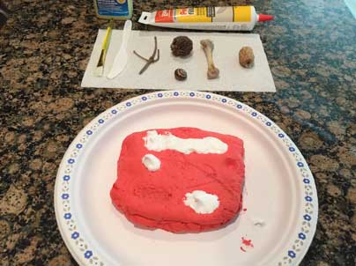

Questions:

Think about the following questions very carefully. Then, type answers in the spaces provided. When you have your answers, click the questions in the online course for feedback.

- Which type of object makes the best trace fossils?

- Which type of object makes the best mold fossils?

- Which type of object makes the best cast fossils?

- How would you make a mineralized (petrified) fossil?

- Why are the objects shown in the photographs here all good examples to use in a fossil lab?

