Science 7
Unit E, Lesson 15
Try It!
Fossil Reconstruction

Try this simple model of fossil reconstruction. What seems like an impossible puzzle at first gets easier if you have access to helpful information and other paleontologists work.
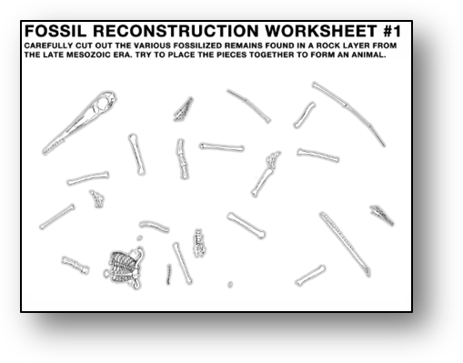
In 1812 Samuel Thomas von Soemmering was the first paleontologist to successfully reconstruct a certain type of fossilized creature. You will follow in his footsteps and attempt to discover what type of organism his work helped to better understand.

Materials:

- Worksheet #1 - Random Fossilized Remains
- scissors
- Worksheet #2 – Fossil Reconstruction (Worksheet #2 is at the very end of this document)

Instructions:

- Print Worksheet #1 - Random Fossilized Remains. Carefully cut out all of the fossil pieces on the page.
- Try placing together as many of the pieces as you can without using any hints or doing any further research. Note which pieces you work with the most.
- When you have tried your best to put the pieces together, flip to Worksheet #2 - Observations and Inferences. Make a short list of observations and inferences about the fossils and the organism that they belong to.
- Look at HINT 1. This fossilized creature was found nearby as it is shown, with its body twisted but all body parts basically connected.
- Go back to Worksheet #2 - Observations and Inferences (it is at the very end of this document). Make a short list of observations and inferences based on your first hint.
- Look at HINT 2. You and your team have managed to fully reconstruct your fossil creature. Return to Worksheet #2 - Observations and Inferences (it is at the very end of this document). Make a short list of observations and inferences based on this second hint.
- Look at HINT 3. This is another fossil that was recently discovered in another country. It appears to match part of your fossil. Compare the new fossil and your creature. Return to Worksheet #2 - Observations and Inferences (it is at the very end of this document). Make a short list of observations and inferences based on this third hint.
- For HINT 4, your team discovers some trace fossils near the original site where your fossil was found. The tracks found match your fossils front and back feet; it appears the creature walked on all fours. Make additional notes or sketches on your previous guess.

Questions:

Think about the following questions very carefully. Then, type answers in the spaces provided. When you have your answers, click the questions in the online course for feedback.

- Which step in the process was the most difficult?

- Which step in the process was the most helpful?

- What type of creature do you think your fossils belong to?

Try It!
Fossil Reconstruction
Worksheet #2 - Observations and Inferences

 | OBSERVATIONS | INFERENCES
FOSSIL PIECES
HINT-01
HINT-02
HINT-03
HINT-04

