Science 7
Unit E
Lesson 15
Self-Check Quiz

Answer all 5 questions in the spaces provided. Think carefully before typing your answers. If you need help, return to the lesson in the online course. Save your quiz when you are done.

Leave your answers in blue; it will be easier for you and your teacher to see them later.

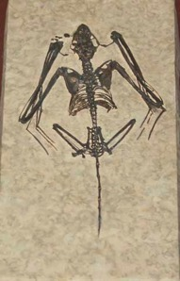
Question 1

Fossils of this type of mammal are very rare. Today, they are a common and very diverse type of mammal found all over the world.

You can guess here! What type of fossil is this, and why is it so rare?

Type your answer here.

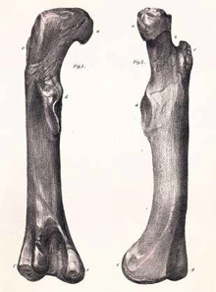
Question 2

One of the earliest recorded fossil discoveries was this femur, 400 years ago in England. The femur is also known as the thigh bone.

The scientists who discovered it thought it belonged to a human giant who had died in the area. Why might the scientists have inferred this from the femur fossil they found? What type of animal might the fossil femur actually be from?

Type your answer here.

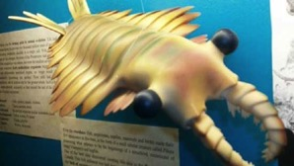
Question 3

The Burgess Shale in British Columbia is one of the most famous fossil sites in the world. One of the most amazing discoveries in the Burgess Shale was the fossilized remains of Anomalocaris, a 2-metre-long water predator with amazingly complex eyes.

When did Anomalocaris live on Earth? What makes the Burgess Shale such an amazing site for finding fossils?

Type your answer here.

Question 4

A very interesting group of organisms alive on Earth right now are called ‘living fossils’. Why do you think they are referred to as ‘living fossils’? Suggest one example of this strange group.

Type your answer here.

Question 5

The fossil record can be very complex and very weird in some places. For example, currently, a ‘living fossil’ is considered to be the closest living relative of birds although it is carnivorous and lives mostly in the water. Which living fossil do you think is the closest living relative of birds? What is the connection between these two very different groups of animals?

Type your answer here.

Congratulations! You have completed this self-check quiz.

Now it's time to carefully compare your answers to the suggested answers in the online course. When comparing, you should feel free to make changes to your answers or make extra notes.

Don't forget to save the quiz whenever you make changes.

Keep this quiz for study purposes. If you want more feedback, share it with your teacher.

