Science 7
Unit E
Lesson 17
Self-Check Quiz

Answer all 5 questions in the spaces provided. Think carefully before typing your answers. If you need help, return to the lesson in the online course. Save your quiz when you are done.

Leave your answers in blue; it will be easier for you and your teacher to see them later.

Question 1

The geologic time scale is a model of how living things have changed over long periods. What are the main strength and the main weakness of this model?

Type your answer here.

Question 2

The Cenozoic (“Age of the Mammals”) and Mesozoic (“Age of the Dinosaurs”) have nicknames. What would you nickname the Paleozoic and Precambrian Eras?

Type your answer here.

Question 3

In what way could a mass extinction be considered a good thing?

Type your answer here.

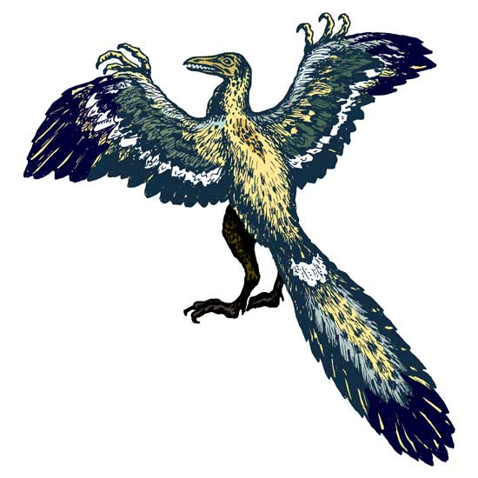
Question 4

Archaeopteryx was an important creature on the geologic time scale.

It had claws and teeth, but it had feathers, too. It lived about 150 million years ago, during the Jurassic period of the Mesozoic Era. Why is the knowledge of Archaeopteryx so important?

Type your answer here.

Question 5

What is significant about the way the end of the Precambrian is different from the end of other eras?

Type your answer here.

Congratulations! You have completed this self-check quiz.

Now it's time to carefully compare your answers to the suggested answers in the online course. When comparing, you should feel free to make changes to your answers or make extra notes.

Don't forget to save the quiz whenever you make changes.

Keep this quiz for study purposes. If you want more feedback, share it with your teacher.

