Science 7
Unit E, Lesson 18
Lesson Activity
How Old Is That?

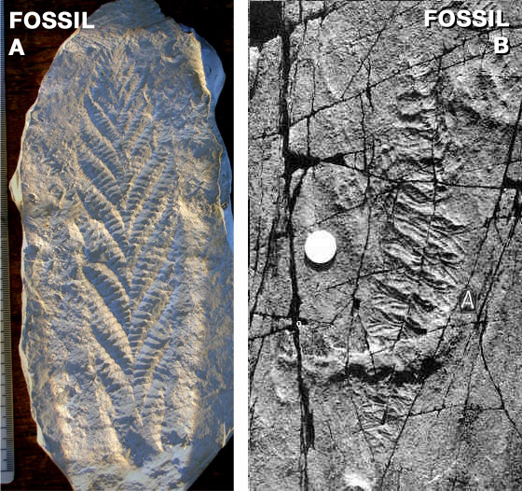
Determining the age of a fossil requires careful observation. The fossil, the rock in which it is found, and the location of the rock are all very important in estimating a fossil’s age. Even then, someone might make a new discovery tomorrow that will change everything you thought you knew about your fossil.

Materials:

- How Old Is That? Worksheet - Observations and Inferences for Two Unknown Fossils (pages 2 & 3 of this document).
The first unknown fossil to be studied in this lesson was provided by Smith609.
The second unknown fossil presented in this lesson was provided by Mistakenpoint.

Instructions:

- Print the "How Old Is That?" worksheet, you will find it on the next two pages of this document.

- Every time you see FOSSIL CHECK, take out your worksheet and record one or two observations you have about the unknown fossils. Then, make one or two inferences that relate to your observation

- Later in this lesson, you will compare your worksheet to another set of observations, and answer some questions.

How Old is That? FOSSIL A

 | OBSERVATIONS | INFERENCES
FOSSIL A | - about 20 cm long, 6 cm wide  - equal branches extend out from middle  - this is a mold fossil | - it might have grown upwards  - similar to how many plants grow  - the organism was solid enough to leave a mold
FOSSIL CHECK 1 | -  -  - | -  -  -
FOSSIL CHECK 2 | -  -  - | -  -  -
FOSSIL CHECK 3 | -  -  - | -  -  -
FOSSIL CHECK 4 | -  -  - | -  -  -

How Old is That? FOSSIL B

 | OBSERVATIONS | INFERENCES
FOSSIL B | - about 20 cm long, 4 cm wide  -  - | -  -  -
FOSSIL CHECK 1 | -  -  - | -  -  -
FOSSIL CHECK 2 | -  -  - | -  -  -
FOSSIL CHECK 3 | -  -  - | -  -  -
FOSSIL CHECK 4 | -  -  - | -  -  -

Questions:

Think about the following questions very carefully. Then, type answers in the spaces provided. When you have your answers, click the questions in the online course for feedback.

- When you first saw the fossils, what inferences did you make about them? Why did you make these particular inferences?

- Can you tell if a fossil is very important just by looking at it? Explain.

- What are some of the most important observations that can be made when a fossil is first discovered?

