Science 7
Unit E
Lesson 18
Self-Check Quiz

Answer all 5 questions in the spaces provided. Think carefully before typing your answers. If you need help, return to the lesson in the online course. Save your quiz when you are done.

Leave your answers in blue; it will be easier for you and your teacher to see them later.

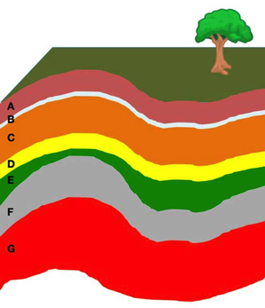
Question 1

The image to the right indicates several types of rocks.

What are the youngest rocks and the oldest rocks shown in the image? Explain how you know this is true.

Type your answer here.

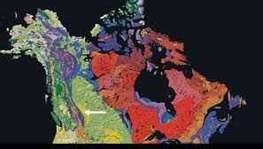
Question 2

On the geologic map of Canada, the oldest rocks are from the Precambrian Era, and they are labelled red and pink. Purple is rock from the Paleozoic, green is from the Mesozoic, and yellow is from the Cenozoic.

If you drilled a deep well straight down somewhere in Alberta at a site located in the yellow zone shown on the map, what would you expect to see in a core sample?

Type your answer here.

Question 3

Rarely do igneous rocks contain important fossils although it is not impossible. Why might this be so? What fossils might be found in igneous rocks? How would the age of these fossils be determined?

Type your answer here.

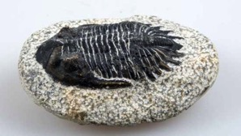
Question 4

Trilobites are one of the best index fossils we have for several reasons.

Trilobites were a type of arthropod (insects) that shed their hard shells frequently as they grew. How has this helped them to become an important index fossil?

Type your answer here.

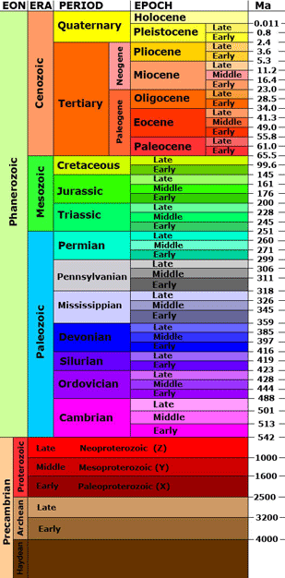
Question 5

The geologic time scale shows Earth’s history of life.

How do scientists know the exact beginnings and endings of the various time periods on the geologic time scale? Explain why changes likely will be made to the geologic time scale in the future.

Type your answer here.

Congratulations! You have completed this self-check quiz.

Now it's time to carefully compare your answers to the suggested answers in the online course. When comparing, you should feel free to make changes to your answers or make extra notes.

Don't forget to save the quiz whenever you make changes.

Keep this quiz for study purposes. If you want more feedback, share it with your teacher.

