Science 7
Unit E
Lesson 4
Self-Check Quiz

Answer all 5 questions in the spaces provided. Think carefully before typing your answers. If you need help, return to the lesson in the online course. Save your quiz when you are done.

Leave your answers in blue; it will be easier for you to see them later.

Question 1

Why is the moment magnitude scale (MMS) now used instead of the Richter scale to measure the strength of earthquakes?

Type your answer here.

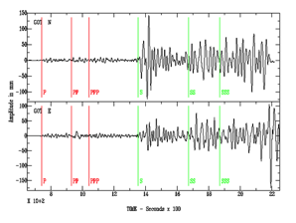
Question 2

This is a seismogram from the 1906 San Francisco earthquake.

- What do the squiggly lines represent?

Type your answer here.

- Why are the squiggles on the left smaller than those on the right?

Type your answer here.

- How long did the people living near this seismograph have between the first foreshocks they could feel and the damaging shaking?

Type your answer here.

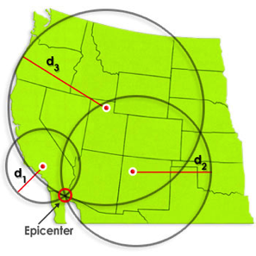
Question 3

Triangulation used to find an earthquake’s epicentre.

- In the image, what devices are found at the locations labelled with the red dots?

Type your answer here.

- What do the lines labelled d1, d2, and d3 represent?

Type your answer here.

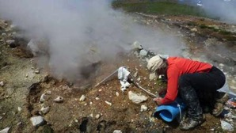
Question 4

A volcanologist is a geologist who specializes in learning about volcanoes.

This volcanologist is collecting samples of the gases released. What are four other methods that are used to observe, measure, and predict volcanic eruptions?

Type your answer here.

Question 5

If you were searching for locations that had gems, explain which tests you would want to do first, and why you would choose that type of test?

Type your answer here.

Congratulations! You have completed this self-check quiz.

Now it's time to carefully compare your answers to the suggested answers in the online course. When comparing, you should feel free to make changes to your answers or make extra notes.

Don't forget to save the quiz whenever you make changes.

Keep this quiz for study purposes. If you want more feedback, share it with your teacher.

