social studies 9
UNIT 5: Section 2

Issues through Images

Complete the following chart.

- What are the positive impacts (+) and the negative impacts (–) on the environment and your quality of life depicted in each of the images?
- Describe your thoughts about each image.

The positive and negative impacts for the first photograph are given an example. (You need to include your own thoughts about the first image.)

Image | Positive Impact  (+) | Negative Impact  (–) | Your Thoughts About This image
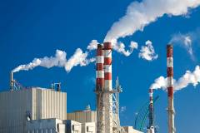  © Goncalo Veloso de Figueiredo/shutterstock  paper factory | The factory is building products for use by Canadians and for possible export. | During production, there are by-products such as CO₂. This causes pollution and climate change, as well as health concerns such as breathing problems for many Canadians. | < >
  © wrangler/shutterstock  gasoline vehicles | < > | < > | < >
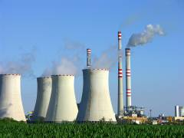  © Kodda/shutterstock  coal-fired power plant | < > | < > | < >
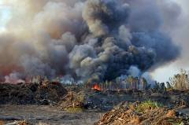  © Samuel Acosta/shutterstock  clear cutting of forest for ranching | < > | < > | < >
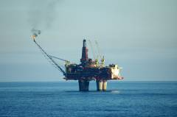  © Ingvar Tjostheim/shutterstock  offshore oil rig | < > | < > | < >
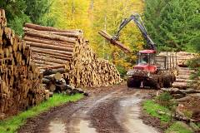  © Ales Liska/shutterstock  heavy forest machinery | < > | < > | < >
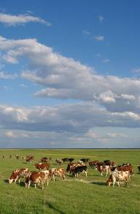  © 2009 Jupiterimages Corporation  cattle ranching | < > | < > | < >
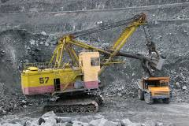  © Konstantin Mironov/shutterstock  opencast mine excavation | < > | < > | < >
What common environmental issue do these images communicate?

< >
What is your opinion on this common environmental issue?

< >
How do these environmental issues affect your quality of life?

< >

Save your completed handout to your Activities folder.

