Science 8
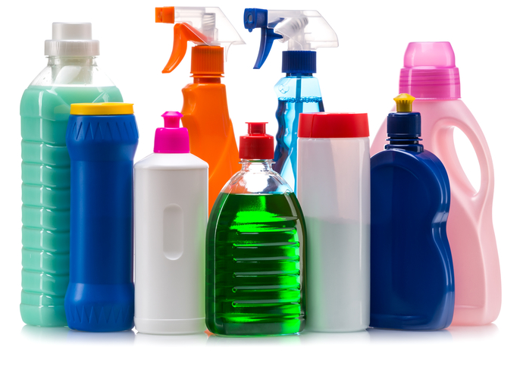
Unit A Lesson 1
Try It!
Household Chemical Inventory

What kinds of hazardous chemicals are around your home? Are they stored safely? What precautions should you take with those chemicals?
Try this activity to create an inventory of the dangerous chemicals in your home.

Materials:

- Chemical inventory chart (last page of this document)
- Pencil

SAFETY WARNING:
Do not handle any chemicals in this activity. Do not touch bottles of chemicals. You only need to LOOK at them. If you need a bottle moved so you can read the label, ask an adult for assistance.

Instructions:

- The last page of this document is the chemical inventory chart. You can print it and fill it in with a pencil, or you can type directly into this document.
- Look around your home and garage for at least 5 hazardous chemicals. Remember to look only, DO NOT TOUCH. Some common ones to look for are cleaners, garden fluids, car fluids, and compressed gases.
- Fill out the chemical inventory chart for each chemical. List the chemical’s name and location. Look on the bottle for WHMIS symbols and warnings and list these hazards. Remember to look only, DO NOT TOUCH – if you need to move a bottle, get an adult to help you. Look on the bottle for any safety precautions and list these too.
- Take a careful look through your completed inventory chart, and use the chart to consider the following questions. Are all the dangerous chemicals in your home stored safely? They should be out of the reach of young children, and following the safety precautions. If not, are there changes you can make to ensure that all chemicals in your home are stored safely?

Questions:

Think about the following questions very carefully, then type or write your answers. Once you have your answers, click on the questions in the online course for feedback.

- Are all the dangerous chemicals in your home stored safely?

- Are there changes you can make to ensure that all chemicals in your home are stored as safely as possible?

Keep scrolling this document – last page (below) is the chemical inventory chart.

Chemical Inventory Chart

Chemical Name | Location | WHMIS Symbol | Safety Hazard | Precautions

