Science 8
Unit A
Section 1
Self-Check Quiz

Answer all 5 questions in the spaces provided. Think carefully before typing your answers. If you need help, return to the lesson in the online course. Save your quiz when you are done.

Leave your answers in blue; it will be easier for you and your teacher to see them later.

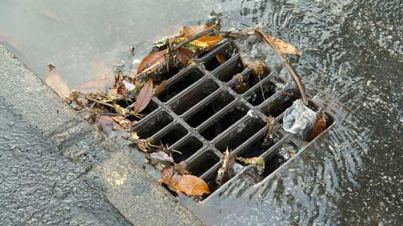
Question 1

Storm sewer drains carry rainwater off streets and down pipes to nearby rivers and streams. Why should people not pour old chemicals down storm sewer drains?

Type your answer here.

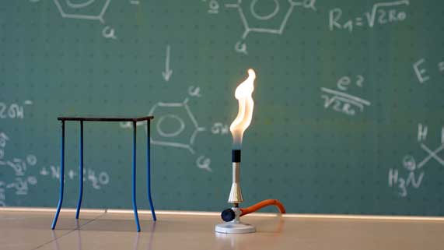
Question 2

A girl with long hair is working in a science lab with an open flame burner. What are two safety measures should she take?

Type your answer here.

Question 3

Describe two fluids that you use and depend on everyday.

Type your answer here.

Question 4

Why are solids not considered to be fluids?

Type your answer here.

Question 5

Most homes contain hazardous chemicals. Describe two ways that you can safely store and handle hazardous materials in your home.

Type your answer here.

Congratulations! You have completed this self-check quiz.

Now it's time to carefully compare your answers to the suggested answers in the online course. When comparing, you should feel free to make changes to your answers or make extra notes.

Don't forget to save the quiz whenever you make changes.

Keep this quiz for study purposes. If you want more feedback, share it with your teacher.

