
Science 8
Unit A, Section 1
Project
Teaching Children About Hazardous Fluids

The following project is to be submitted to your teacher for marking. Read the project and the method very carefully. Be sure to read the rubric because it provides the expectations for this project.

Situation

Your local poison control centre wants to teach young children how to be safe around dangerous household chemicals.

The adults in charge of this project want input from young people such as you on how to teach children about hazardous chemical safety.

This video shows an example of teaching children about poisons: https://www.youtube.com/watch?v=YZO-drzD1_M

Project Task

Design a way to teach children aged 5 to 9 about hazardous chemical safety.

Your teaching method should show imagination and creativity, but it should clearly inform young children about the dangers of common household fluids. It should also teach children how to be safe around hazardous substances.

Before you begin designing your teaching method, ask yourself these questions:
- What information should young children know so they can stay safe?
- How can I communicate this information in a way that is easy for young children to understand?

How

Choose the way you would like to teach children about hazardous household fluids. Here are some ideas from which you can choose:
- Write and illustrate a children’s story book. Draw pictures with pencil and paper, or use a computer drawing program such as Adobe Photoshop or Gimp.
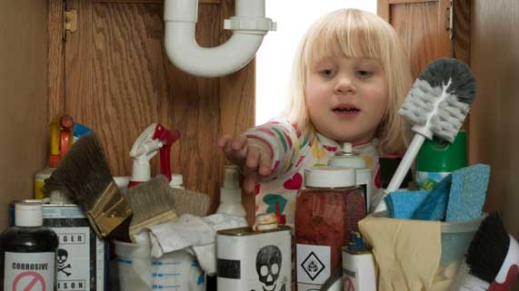
- Write a song. Record your song to share with your teacher.
- Make a video or TV show. Use live acting, or stop-motion animations.
- Create a board game.
- Use other creative ideas, but check with your teacher first!

Requirements

You must clearly communicate the following information in your hazardous fluids teaching method:
- What are five WHMIS symbols? What do these symbols look like?

- What are five examples of common household fluids that contain these WHMIS symbols?

- Explain the dangers that each of the five WHMIS symbols communicates.

- Explain the safety measures a child should take when they see each of these five WHMIS symbols.

Rubric

A rubric explains how your work will be evaluated. It explains clearly all the aspects you must include in your project. Read it very carefully before you start your work.

Teaching Children About Hazardous Fluids
24 marks

CRITERIA | PERFORMANCE
CRITERIA |  | NOT OK | OK | GOOD | EXCELLENT
CRITERIA | Not Submitted  0 marks | Does not  meet criteria  1 mark | Minimally  meets criteria  2 marks | Fully  meets criteria  3 marks | Exceeds  criteria  4 marks
5 WHMIS symbols listed with supporting pictures | Not  Submitted | No WHMIS symbols listed or explained; no supporting pictures shown. | 1 or 2 WHMIS symbols listed or explained; no supporting pictures shown. | 3 or 4 WHMIS symbols listed or explained; some supporting pictures shown. | 5 WHMIS symbols listed or explained; supporting pictures shown.
Each WHMIS symbol connected to a household fluid | Not  Submitted | No WHMIS symbols connected to household fluids; details lacking. | 1 or 2 WHMIS symbols connected to household fluids; details lacking. | 3 or 4 WHMIS symbols connected to household fluids; some supporting details. | 5 WHMIS symbols connected to household fluids; many supporting details.
Fluid dangers listed and connected to WHMIS symbols | Not  Submitted | No fluid dangers listed or connected to WHMIS symbols; details lacking. | Dangers mentioned but not connected to WHMIS symbols; details lacking. | Dangers mentioned and connected to WHMIS symbols; some supporting details. | Dangers mentioned and connected to WHMIS symbols; many supporting details.
Safety measures listed and connected to WHMIS symbols | Not  Submitted | No safety measures listed or connected to WHMIS symbols; details lacking. | Safety measures mentioned but not connected to WHMIS symbols; details lacking. | Safety measures mentioned and connected to WHMIS symbols; some supporting details. | Safety measures mentioned and connected to WHMIS symbols; many supporting details.
Creativity | Not  Submitted | Teaching method is very simple and lacks imagination. | Teaching method is very simple but shows some imagination. | Teaching method has a few details and shows some imagination. | Teaching method has many details and shows a great deal of imagination.
Communication | Not  Submitted | Information is not clearly communicated for children; details lacking. | Information is partly communicated for children; some details lacking or confusing. | Information is partly communicated for children; many details included. | Information is clearly communicated for children, with much detail.

Submitting Your Work

If you do this task as pencil drawing(s) on another piece of paper, you will have to scan your work to submit it.

If you have prepared any other electronic images or documents for this task, you will need to submit them. The same goes for any Internet location where your work is located, you will need to submit the URL so your teacher can view your work.

When you are ready to submit your completed project, return to the Unit A Section 1 Project page in your online course and click the “Add submission” button at the bottom of the page and follow the directions.

Note that when you submit anything to your teacher, PLEASE INCLUDE YOUR NAME IN THE DOCUMENT TITLE. For example, you might title it something like this:

UnitA_Section1project_Jenny_Smith.doc

