Science 8
Unit A
Lesson 3
Self-Check Quiz

Answer all 5 questions in the spaces provided. Think carefully before typing your answers. If you need help, return to the lesson in the online course. Save your quiz when you are done.

Leave your answers in blue; it will be easier for you and your teacher to see them later.

Question 1

You are drawing a picture on paper with a water-soluble purple marker. You accidentally spill a few drops of water on your drawing. After the paper dries, you notice that there are red and blue streaks on the paper. What is the best explanation for this observation?

Type your answer here.

Question 2

If you leave a bottle of ginger ale pop open overnight, it still tastes sweet but isn’t fizzy anymore. Explain this observation using the words “solution” and “dissolved”.

Type your answer here.

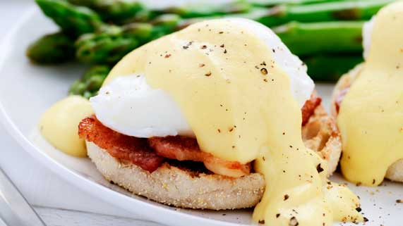
Question 3

If you leave a bottle of ginger ale pop open overnight, it still tastes sweet but isn’t fizzy anymore. Explain this observation using the words “solution” and “dissolved”.

You can’t make a smooth sauce with just butter and lemon juice. Why are eggs needed in hollandaise sauce?

Type your answer here.

Question 4

You accidentally get some permanent marker on your favourite clothes. Water doesn’t work to wash it out. What else could you try to remove this stain?

Type your answer here.

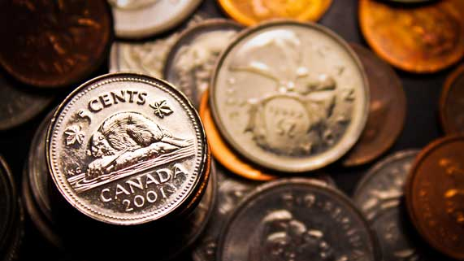
Question 5

Nickels, dimes, and quarters are made of steel and copper alloys, with a thin layer of nickel on the surface.

Suggest a reason why coins mostly contain a steel and copper alloy, with a coating on top.

Type your answer here.

Congratulations! You have completed this self-check quiz.

Now it's time to carefully compare your answers to the suggested answers in the online course. When comparing, you should feel free to make changes to your answers or make extra notes.

Don't forget to save the quiz whenever you make changes.

Keep this quiz for study purposes. If you want more feedback, share it with your teacher.

