Science 8
Unit A
Lesson 5
Self-Check Quiz

Answer all 5 questions in the spaces provided. Think carefully before typing your answers. If you need help, return to the lesson in the online course. Save your quiz when you are done.

Leave your answers in blue; it will be easier for you and your teacher to see them later.

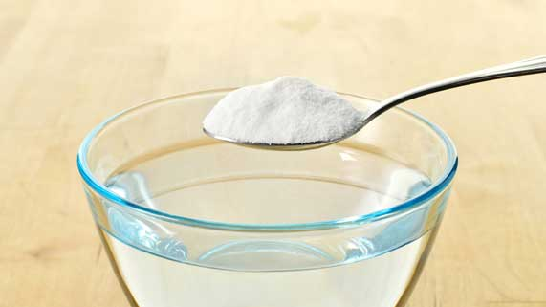
Question 1

You are baking cookies. The recipe recommends to dissolve 1 teaspoon of baking soda in 4 tablespoons of warm water before adding it to the cookie dough.

What is the best explanation for why the recipe tells you to dissolve baking soda in warm water?

Type your answer here.


Question 2

Explain why coffee beans need to be ground into a fine powder before they can be used to brew coffee.

Type your answer here.

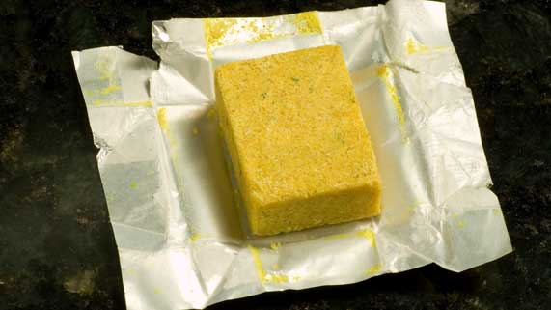
Question 3

Bouillon cubes are made from dehydrated vegetables, spices, and salt. They are added to soups and stews for flavour.

Bouillon cube packages recommend stirring the cube in boiling water before adding it to soup. What is the best explanation for this?

Type your answer here.

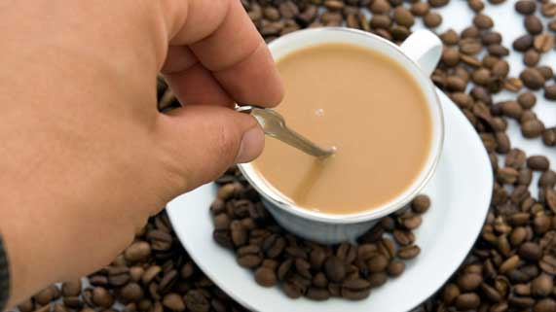
Question 4

Why do people stir their coffee or tea after adding cream or sugar?

Type your answer here.

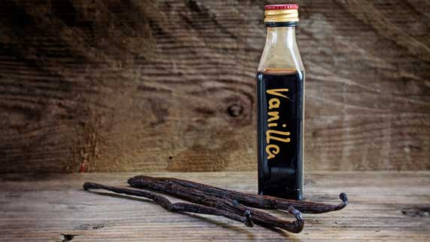
Question 5

Flavoured extracts for baking, such as vanilla extract, use alcohol as a solvent instead of water. What is the best explanation for this?

Type your answer here.

Congratulations! You have completed this self-check quiz.

Now it's time to carefully compare your answers to the suggested answers in the online course. When comparing, you should feel free to make changes to your answers or make extra notes.

Don't forget to save the quiz whenever you make changes.

Keep this quiz for study purposes. If you want more feedback, share it with your teacher.

