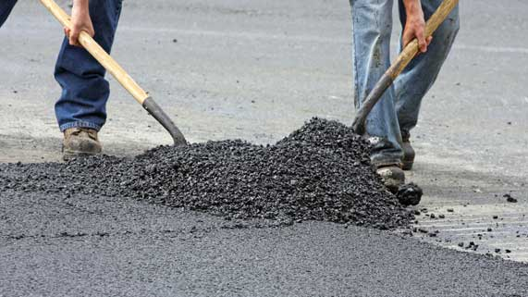
Science 8
Unit A, Lesson 6
Lesson Activity
Separating Mixtures

Problem:

Your task in this experiment is to design and test a procedure to separate a mixture of sand, salt, gravel, and oil.

Hypothesis:

A hypothesis is a testable answer to a scientific question. In other words, what do you think the result of this activity will be? Write your hypothesis in the red box.

What follows is a sample hypothesis. How does it compare to your own?

Hypothesis: By using the appropriate solvents and filters, sand, salt, gravel, and oil can be separated from one another.

Materials:

- Sand
- Salt
- Gravel
- Vegetable oil
- Large jar
- Cups (plastic or glass)
- Coffee filters
- Mesh strainer
- Eyedropper or turkey baster
- Water
- Funnel
- Cooking pot
- Stove
- Any other materials that are useful to complete the task

Safety Warning

You may choose to use a hot stove in this experiment. If so, it must be completed with the supervision and assistance of an adult.
DO NOT attempt to use a stove by yourself.
Hot fluids and metal can burn you or others if you are not careful.
Wear oven mitts when handling hot containers
Never leave a hot stove unattended.
Take care when pouring hot fluids.

Instructions:

- Design and write a procedure to completely separate a mixture of sand, salt, gravel, and oil. You can use any of the materials listed above, or additional materials as you wish. Your procedure should be written as numbered steps. The mixture components need to be completely separated – so you can’t end up with oily rocks or sand!

Before you start writing your procedure, consider these questions:

- Are there ways to physically separate or filter any of the mixture components?
- Are there ways to separate any of the mixture components using solubility?
- What substances in the mixture are soluble? In what solvents?
- What substances in the mixture are insoluble? In what solvents?
- Which substances would be easiest to separate first?

Your Procedure:

Use the following space to write your procedure. Remember, numbering your steps will help you will help you to keep organized. There are 5 empty steps below, but you can use as many steps as you need.

Step 1.

Step 2.

Step 3.

Step 4.

Step 5.

Instructions Continued:

- In a large jar, make a mixture of sand, salt, gravel, and oil. Put approximately ½ cup of each substance in the jar. Shake the mixture well.

- Test your procedure. If you are not successful the first time, adjust your procedure and try again until you are successful at separating all four components.

Analysis Questions:

Think about the following questions very carefully. Then, type answers in the space provided. When you have your answers, click the questions in the online course for feedback.

- How did you separate oil from the mixture? Explain why this worked, referring to the particle model of matter.

- How did you separate gravel from the mixture? Explain why this worked, referring to the particle model of matter.

- How did you separate sand from the mixture? Explain why this worked, referring to the particle model of matter.

- How did you separate salt from the mixture? Explain why this worked, referring to the particle model of matter.

Sharing:

Congratulations on completing this activity! Consider sharing your completed work (or any thoughts you might have on this activity) in the course Sharing Forum.

You can also email your completed work to your teacher and ask for feedback.

