Science 8
Unit A
Lesson 6
Self-Check Quiz

Answer all 5 questions in the spaces provided. Think carefully before typing your answers. If you need help, return to the lesson in the online course. Save your quiz when you are done.

Leave your answers in blue; it will be easier for you and your teacher to see them later.

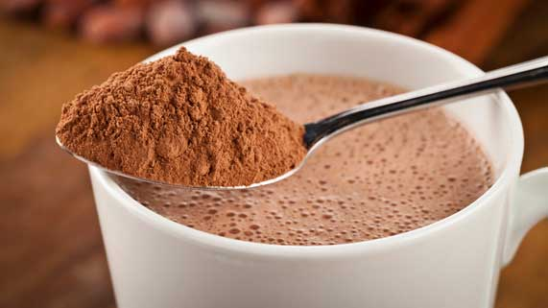
Question 1

Hot chocolate powder dissolves faster in hot milk compared to cold milk. Explain this observation, using the particle model of matter.

Type your answer here.

Question 2

An open can of soda pop loses its fizz and goes flat quickly on a hot day. Explain this observation, using the particle model of matter.

Type your answer here.

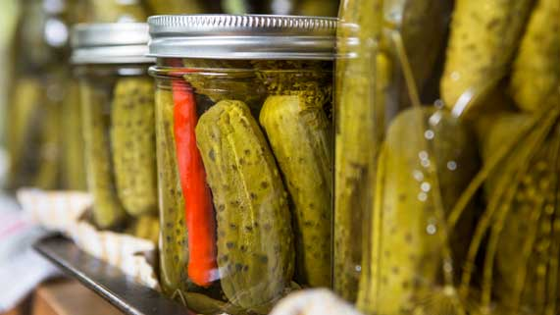
Question 3

To make pickles, brine is added to small cucumbers. Brine is a solution of water, rock salt, and vinegar. People canning pickles stir and heat a big pot of water, rock salt, and vinegar before adding brine to the cucumbers.

Using the particle model of matter, explain why it is better to make a solution of hot brine instead of adding salt and vinegar directly to the pickle jars.

Type your answer here.

Question 4

Explain one advantage and one disadvantage of desalination.

Type your answer here.

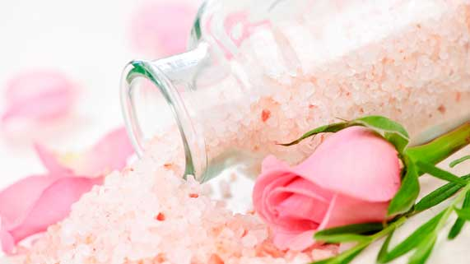
Question 5

People sometimes add scented Epsom salts to their bath. When you pour Epsom salts into a bathtub, the salt crystals often sit at the bottom of the tub and take time to dissolve.

Explain this observation, using the particle model of matter.

Type your answer here.

Congratulations! You have completed this self-check quiz.

Now it's time to carefully compare your answers to the suggested answers in the online course. When comparing, you should feel free to make changes to your answers or make extra notes.

Don't forget to save the quiz whenever you make changes.

Keep this quiz for study purposes. If you want more feedback, share it with your teacher.

