Science 8
Unit A
Section 2
Self-Check Quiz

Answer all 5 questions in the spaces provided. Think carefully before typing your answers. If you need help, return to the lesson in the online course. Save your quiz when you are done.

Leave your answers in blue; it will be easier for you and your teacher to see them later.

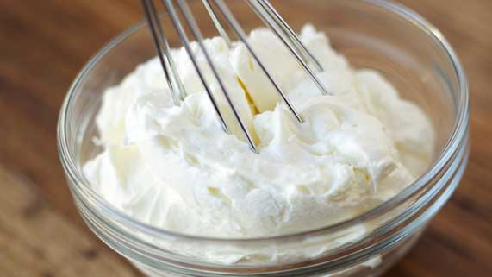
Question 1

Whipped cream is a mixture of heavy cream and air. What type of mixture would you consider whipped cream to be? Explain your answer.

Type your answer here.

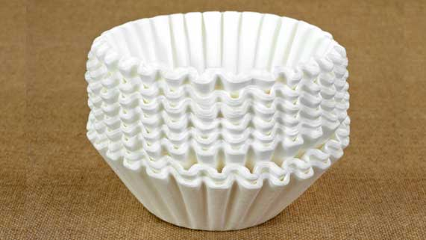
Question 2

Your friend says that he can clean the salt out of ocean water by running it through a coffee filter and capturing the salt left behind.

Using the particle model of matter, how could you explain to your friend the reasons why his method won’t be successful? What method of separating salt from water could you suggest to your friend instead?

Type your answer here.

Question 3

While you are camping, you accidentally spill a bag of sugar on the ground and it mixes with some sand. You’re too far away from a store to buy more sugar. You have a coffee filter, a cup, a camping stove, a cooking pot, and water. How could you clean the sugar so it’s usable again? Explain your method.

Type your answer here.

Question 4

If you put wet meat into a pan of hot oil, the oil splatters out of the pan. Explain this observation.

Type your answer here.

Question 5

Salty ocean water stings our eyes, while saline solution in eye drops doesn’t hurt. How would you describe the relative concentrations of these two salt solutions?

Type your answer here.

Congratulations! You have completed this self-check quiz.

Now it's time to carefully compare your answers to the suggested answers in the online course. When comparing, you should feel free to make changes to your answers or make extra notes.

Don't forget to save the quiz whenever you make changes.

Keep this quiz for study purposes. If you want more feedback, share it with your teacher.

