Science 8
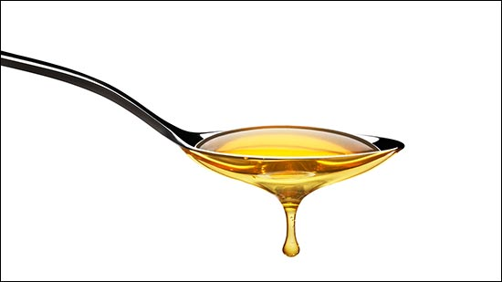
Unit A, Lesson 7
Lesson Activity
Viscosity Ramp Test

Problem:

Out of five fluids, which one has the highest viscosity? Which one has the lowest viscosity? Design and test a ramp test experiment to find the answer.

Hypothesis:

A hypothesis is a testable answer to a scientific question. In other words, what do you think the result of this activity will be? Before you make your own hypothesis, you should think about the manipulated, responding, and controlled variables in this activity.

Write your hypothesis in the red box.

What follows is a sample hypothesis. How does it compare to your own?

Hypothesis: The fluid that moves that fastest down a ramp has the highest viscosity. The fluid that moves the slowest down a ramp has the lowest viscosity.

Materials:

- Maple syrup
- Oil
- Honey
- Water
- Dish detergent
- Cookie sheets (2)
- Old books or wood blocks
- Timer
- Thermometer
- Cups
- Measuring spoons
- Any other materials you think are useful

Instructions:

- Design and write a procedure for this experiment. Write your procedure as numbered steps with enough detail so someone else could easily do the experiment.

Before you start writing your procedure, consider these questions:

- How are you going to measure the responding variable?
- What are all the specific things you need to keep the same in order to make it a fair test?

Your Procedure:

Use the following space to write your procedure. Remember, numbering your steps will help you will help you to keep organized. There are 5 empty steps below, but you can use as many steps as you need.

Step 1.

Step 2.

Step 3.

Step 4.

Step 5.

Instructions Continued:

- Test your procedure and record your results in the following table:

Fluid | Time
Maple Syrup
Oil
Honey
Water
Dish Detergent

Analysis Questions:

Think about the following questions very carefully. Then, type answers in the space provided. When you have your answers, click the questions in the online course for feedback.

- Which fluid had the highest viscosity? What observation indicated the highest viscosity? Explain your answer with the particle model of matter.

- Which fluid had the lowest viscosity? What observation indicated the lowest viscosity? Explain your answer with the particle model of matter.

- List your fluids in order from highest viscosity to lowest viscosity.

Sharing:

Congratulations on completing this activity! Consider sharing your completed work (or any thoughts you might have on this activity) in the course Sharing Forum.

You can also email your completed work to your teacher and ask for feedback.

