Science 8
Unit A
Lesson 7
Self-Check Quiz

Answer all 5 questions in the spaces provided. Think carefully before typing your answers. If you need help, return to the lesson in the online course. Save your quiz when you are done.

Leave your answers in blue; it will be easier for you and your teacher to see them later.

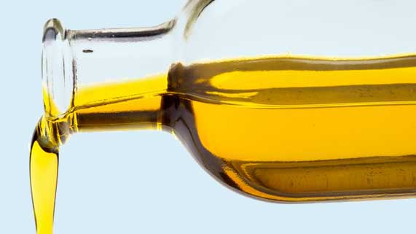
Question 1

At room temperature, olive oil pours easily. How would the viscosity of olive oil change if you put a bottle of olive oil into the fridge?

Type your answer here.


Question 2

You are pouring honey from a bottle. The honey doesn’t flow out of the bottle very easily. How would you describe the viscosity of the honey? What could you do to make the honey flow more easily?

Type your answer here.

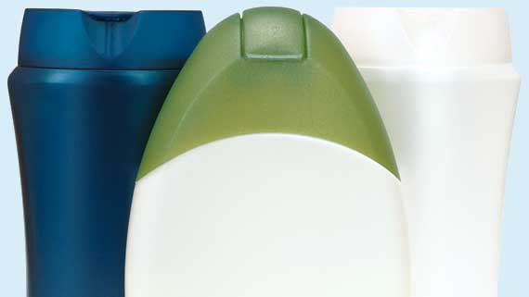
Question 3

When a shampoo bottle is nearly empty, you have to store it upside down to finish the bottle. Why does storing a shampoo bottle upside down help you use up all the shampoo in the bottle?

Type your answer here.

Question 4

Motor oil coats the components of car engines to help all the parts in the engine move smoothly. On very cold days, car engines have trouble starting. Explain why this happens.

Type your answer here.


Question 5

Cough syrup, which soothes throat irritation, is very viscous. How does the viscosity of cough syrup help it work effectively?

Type your answer here.

Congratulations! You have completed this self-check quiz.

Now it's time to carefully compare your answers to the suggested answers in the online course. When comparing, you should feel free to make changes to your answers or make extra notes.

Don't forget to save the quiz whenever you make changes.

Keep this quiz for study purposes. If you want more feedback, share it with your teacher.

