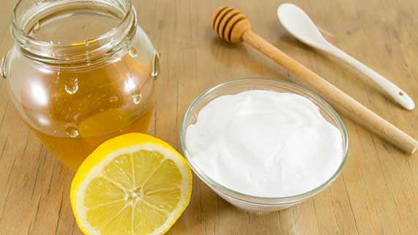
Science 8
Unit A, Lesson 8
Try It!
Comparing Baking Soda and Honey

The mass and volume of baking soda and honey samples were measured and recorded. Use the tables with experimental data below to calculate the density of baking soda and honey.

Instructions and Experimental Data:

Use the provided data for baking soda and honey to calculate density. Because there are four measurements for each substance, you need to do four density calculations for each substance.
There is an answer key at the end of this document – don't peek until you have done your density calculations!

Mass and Volume of Baking Soda

Mass (g) | Volume (mL) | 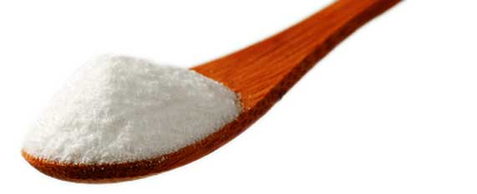  Density (g/mL)
225 | 100
435 | 200
660 | 300
900 | 400

Mass and Volume of Honey

Mass (g) | Volume (mL) | 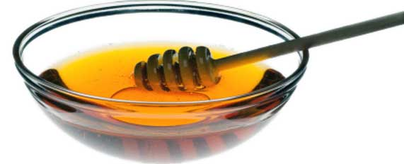  Density (g/mL)
142 | 100
280 | 200
415 | 300
564 | 400

Analysis:

Think about the following questions very carefully. Refer to your observation table. Then, type or write your answers. When you have your answers, click the questions in the online course for feedback.

- As the mass of each substance increased, what happened to its volume?

- As the mass and volume of each substance increased, what happened to its density?

- For 100 mL of volume, which substance had the greater mass?

- For 400 mL of volume, which substance had the greater mass?

- Why are the calculated densities of baking soda very close to each other, but not exactly the same?

- Which substance had the higher density?

- Does changing the mass and volume of a substance change its density? Explain, referring to the particle theory of matter in your answer.

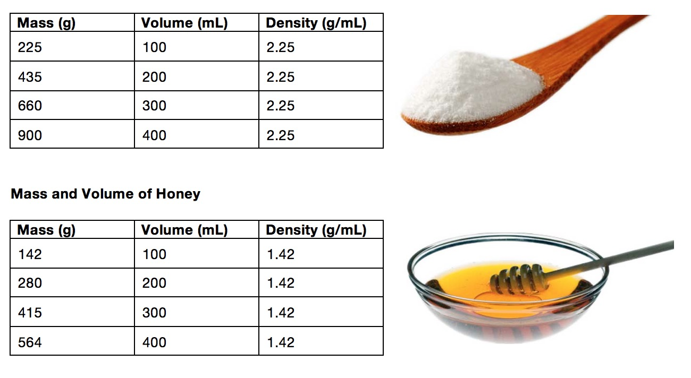
KEY for table:

