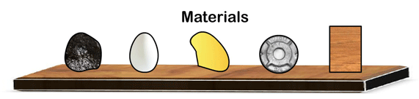
Science 8
charcoalegggoldironoak wood
Unit A, Lesson 8
Lesson Activity
Determining Density

Problem:

How do the densities of five different materials compare with each other?
In this virtual experiment you will measure the mass and volume of five different objects and determine their densities. This experiment uses Archimedes’ discovery of finding an object’s volume by its displacement of water.

Hypothesis: (please write your own hypothesis in the following space)

A hypothesis is a testable answer to a scientific question. In other words, what do you think the result of this activity will be?

Hint: The five objects are charcoal, egg, gold, iron, and oak wood.
- Which object do you think will have the highest density? Why?
- Which object do you think will have the lowest density? Why?

Go to the website http://ippex.pppl.gov/interactive/.
Click on the link for the "Virtual Density Lab".
Click on the "Open in a new window link".
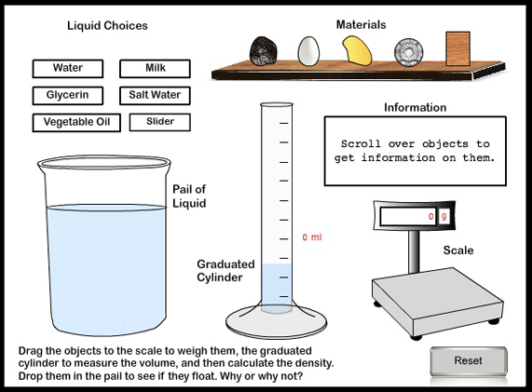

Go to the website http://ippex.pppl.gov/interactive/.
Click on the link for the "Virtual Density Lab".
Click on the "Open in a new window link".

Instructions:

- For the liquid choice, click on water.
- Drag each object to the scale. Measure the mass of each object and record these masses on your observations table.
- Drop each object into the graduated cylinder. Note the volume of water that each object displaces. Record these volumes on your observations table.
- Calculate the density of each object and record these densities in the observations table.

Object | Mass (g) | Volume (mL) | Density (g/mL)
Charcoal
Egg
Gold
Iron
Oak Wood

Analysis Questions:

Think about the following questions very carefully. Then, type answers in the space provided. When you have your answers, click the questions in the online course for feedback.

- Which object had the highest density?

- Which object had the lowest density?

- List the objects in order from highest to lowest density.

