Science 8
Unit A, Lesson 9
Lesson Activity
Virtual Buoyancy

Problem:

How buoyant are different objects in different liquids? In this virtual experiment, you will test the buoyancy of five different objects in three different liquids.

The virtual experiment is found on this website:

http://ippex.pppl.gov/interactive/.
Click on the link for the "Virtual Density Lab".
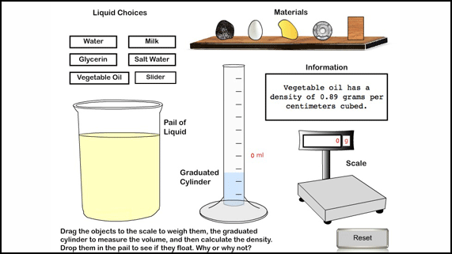
Click on the "Open in a new window link".

Hypothesis: (please write your own hypothesis in the following space.)

A hypothesis is a testable answer to a scientific question. In other words, what do you think the result of this activity will be?

Hint: The five objects are charcoal, egg, gold, iron, and oak wood. The three liquids are fresh water, salt water, and vegetable oil. Before you make your hypothesis, it will help to have more information. Refer to the Determining Density activity you completed in Lesson A8, and copy the densities you calculated for each object into the Observations Table below.

If you did not do the Determining Density activity in Lesson A8, here are the densities for the 5 objects in this activity.

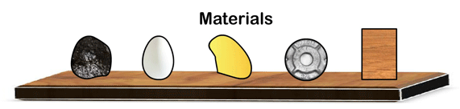
Densities:
charcoalegggoldironoak wood
- Charcoal - 0.208 g/mL
- Egg - 1.02 g/mL
- Gold - 19.3 g/mL
- Iron - 7.8 g/mL
- Oak wood - 0.93 g/mL

Now, (if you haven’t already) it’s time to make your hypothesis. Which objects do you think will float in fresh water? Why? Which objects do you think will float in salt water? Why?

Instructions:

- For the liquid choice, click on water.
- Drag each object to the pail of liquid. Observe if each object floats or not, and record these observations on the table below.
- Change the liquid choice to salt water, and repeat Step 2.
- Change the liquid choice to vegetable oil, and repeat Step 2.

Observations:

Object | Density  (g/mL) | Buoyancy in  Fresh Water  (Density = 1.00 g/mL) | Buoyancy in  Salt Water  (Density = 1.03 g/mL) | Buoyancy in  Vegetable Oil  (Density = 0.89 g/mL)
Charcoal
Egg
Gold
Iron
Oak wood

Analysis Questions:

Think about the following questions very carefully. Then, type answers in the space provided. When you have your answers, click the questions in the online course for feedback.

- Which objects floated in fresh water? Why?

- Which objects sank in fresh water? Why?

- Which objects floated in salt water? Why?

- Which objects sank in salt water? Why?

- Which objects floated in vegetable oil? Why?

- Which objects sank in vegetable oil? Why?

