Science 8
Unit A
Lesson 9
Self-Check Quiz

Answer all 5 questions in the spaces provided. Think carefully before typing your answers. If you need help, return to the lesson in the online course. Save your quiz when you are done.

Leave your answers in blue; it will be easier for you and your teacher to see them later.

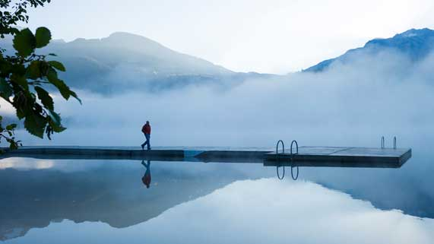
Question 1

Floating docks are sometimes constructed on lakes. The wood used to build a floating dock is very heavy to lift. If wood is heavy, why does a wooden dock float on water?

Type your answer here.

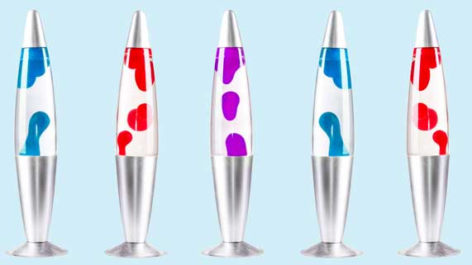
Question 2

Lava lamps are made of water and an oily liquid. When a lava lamp is turned on, the oily liquid heats up and rises to the top of the lamp. At the top of the lamp, the oily liquid cools and sinks back to the bottom.

Explain how lava lamps work, referring to density, buoyancy, and the particle model of matter.

Type your answer here.

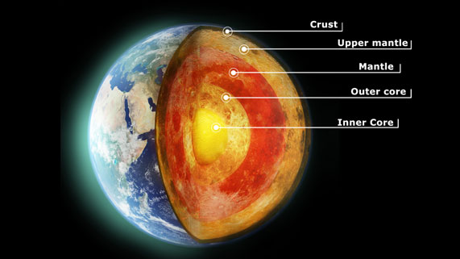
Question 3

The Earth’s solid crust floats on the liquid mantle. Explain this observation.

Type your answer here.

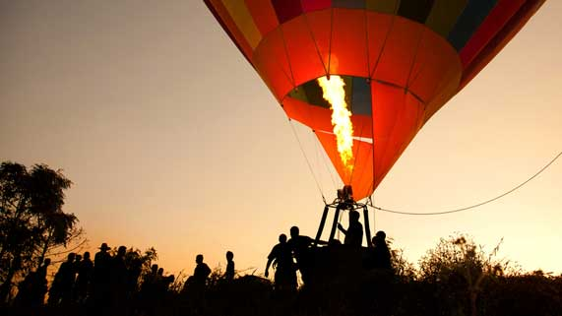
Question 4

Hot air balloons contain propane burners to heat air inside the balloon. Explain how a hot air balloon pilot would cause an airborne balloon to return to the ground.

Type your answer here.

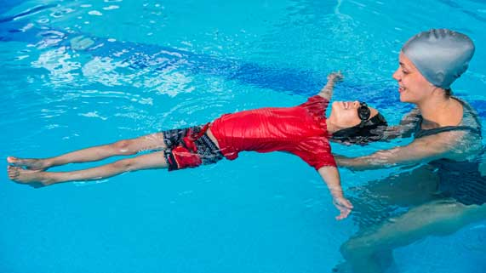
Question 5

Taking a full deep breath can help you float on water better. Explain this observation.

Type your answer here.

Congratulations! You have completed this self-check quiz.

Now it's time to carefully compare your answers to the suggested answers in the online course. When comparing, you should feel free to make changes to your answers or make extra notes.

Don't forget to save the quiz whenever you make changes.

Keep this quiz for study purposes. If you want more feedback, share it with your teacher.

