Science 8
Unit A
Lesson 10
Self-Check Quiz

Answer all 5 questions in the spaces provided. Think carefully before typing your answers. If you need help, return to the lesson in the online course. Save your quiz when you are done.

Leave your answers in blue; it will be easier for you and your teacher to see them later.


Question 1

A woman wearing high-heeled shoes walks across soft ground. Her shoes easily sink into the loose soil. Explain why flat shoes would be a better choice of footwear on soft ground.

Type your answer here.

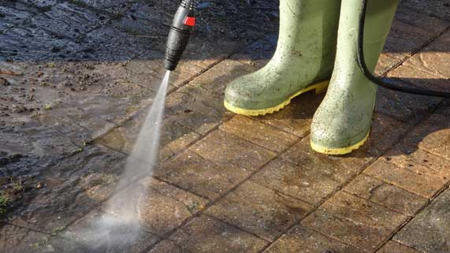
Question 2

Explain why a spray nozzle on a garden hose cleans mud off a driveway more effectively than a hose without a spray nozzle.

Type your answer here.

Question 3

Puncturing a hole in a high-pressure aerosol can will cause the can to explode. Explain this observation, referring to pressure and the movement of gas particles.

Type your answer here.

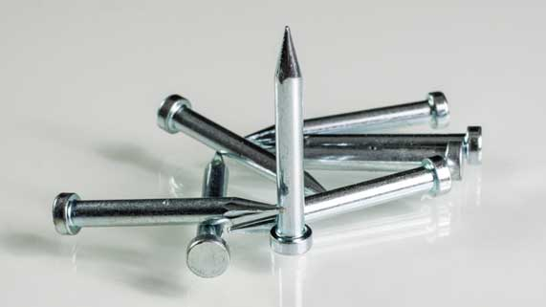
Question 4

Why do sharp tips make nails easier to hammer into wood?

Type your answer here.


Question 5

Why do snowshoes allow people to walk on top of deep snow?

Type your answer here.

Congratulations! You have completed this self-check quiz.

Now it's time to carefully compare your answers to the suggested answers in the online course. When comparing, you should feel free to make changes to your answers or make extra notes.

Don't forget to save the quiz whenever you make changes.

Keep this quiz for study purposes. If you want more feedback, share it with your teacher.

