Science 8
Unit A
Section 3
Self-Check Quiz

Answer all 5 questions in the spaces provided. Think carefully before typing your answers. If you need help, return to the lesson in the online course. Save your quiz when you are done.

Leave your answers in blue; it will be easier for you and your teacher to see them later.

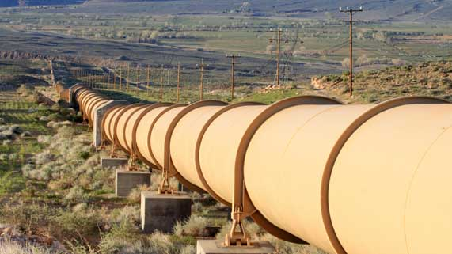
Question 1

Bitumen is a very thick crude oil substance, which is dug out of the oil sands in Northern Alberta. Bitumen has the consistency of peanut butter. Before bitumen is transported through pipelines, it needs to be mixed with other crude oil fluids to form diluted bitumen, or dilbit.

What is the best explanation for why bitumen needs to be diluted before putting it in pipelines?

Type your answer here.

Question 2

Two objects with the exact same mass are put into water. Object 1 displaces 5 mL of water. Object 2 displaces 10 mL of water. Which object has the higher density?

Type your answer here.

Question 3

Liquid 1 has a mass of 10 g in a volume of 2.0 mL. Liquid 2 has a mass of 50 g in a volume of 25 mL. Which liquid will float on top of the other?

Type your answer here.

Question 4

Three different objects are tested for their buoyancy in freshwater and saltwater. The experimental results are listed in the table below.

Object | Buoyancy in Freshwater | Buoyancy in Saltwater
1 | No | Yes
2 | Yes | Yes
3 | No | No

Arrange the objects in order from lowest density to highest density and explain your answer.

Type your answer here.

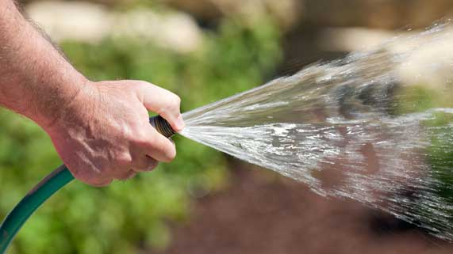
Question 5

Partially covering the opening of a garden hose with your thumb causes the water to spray further. What is the best explanation for this observation?

Type your answer here.

Congratulations! You have completed this self-check quiz.

Now it's time to carefully compare your answers to the suggested answers in the online course. When comparing, you should feel free to make changes to your answers or make extra notes.

Don't forget to save the quiz whenever you make changes.

Keep this quiz for study purposes. If you want more feedback, share it with your teacher.

