Science 8
Unit A
Lesson 11
Self-Check Quiz

Answer all 5 questions in the spaces provided. Think carefully before typing your answers. If you need help, return to the lesson in the online course. Save your quiz when you are done.

Leave your answers in blue; it will be easier for you and your teacher to see them later.

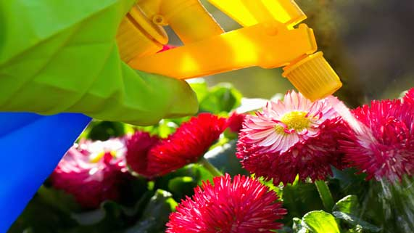
Question 1

Many fertilizers are water-soluble. Explain the advantage of using water-soluble fertilizers.

Type your answer here.


Question 2

Washable markers clean off skin easily with water. Permanent markers do not clean off skin easily with water. Why do washable markers come off skin easily, while permanent markers don’t? What would you suggest to someone trying to clean permanent marker off their skin?

Type your answer here.

Question 3

A man is spreading butter on a piece of toast. He accidentally drops some butter on his shirt. He tries to wash the butter off his shirt with some water, but it leaves a grease stain behind.

Why doesn’t water clean the man’s shirt? What would you suggest that he try instead?

Type your answer here.

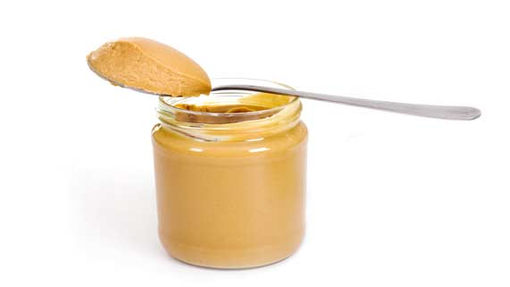
Question 4

If you peel the label off an empty glass jar, sometimes a sticky residue is left behind. Water doesn’t work to wash off the residue. To remove the sticky residue from a glass jar, you can rub some peanut butter on it.

Explain why peanut butter is effective at cleaning sticky residue off jars.

Type your answer here.

Question 5

What are the advantages of mining potash by solution mining, compared to having miners physically dig out potash?

Type your answer here.

Congratulations! You have completed this self-check quiz.

Now it's time to carefully compare your answers to the suggested answers in the online course. When comparing, you should feel free to make changes to your answers or make extra notes.

Don't forget to save the quiz whenever you make changes.

Keep this quiz for study purposes. If you want more feedback, share it with your teacher.

