Science 8
Unit A
Lesson 12
Self-Check Quiz

Answer all 5 questions in the spaces provided. Think carefully before typing your answers. If you need help, return to the lesson in the online course. Save your quiz when you are done.

Leave your answers in blue; it will be easier for you and your teacher to see them later.

Question 1

A tightly crumpled piece of aluminum foil sinks in water, while an identical piece of lightly crumpled aluminum foil floats. What is the best explanation for this observation?

Type your answer here.

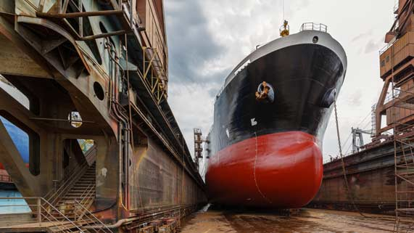
Question 2

Ship hulls are very tall and extend deep underwater. Explain why large ships need to be designed with deep hulls.

Type your answer here.

Question 3

Why is it necessary to dilute bitumen before putting it in pipelines? What problems would be encountered if bitumen was put into pipelines as is?

Type your answer here.

Question 4

Why is multigrade oil a better choice for Canadian cars compared to monograde oil?

Type your answer here.

Question 5

When a boat gets a hole, why does it sink? Refer to density in your explanation.

Type your answer here.

Congratulations! You have completed this self-check quiz.

Now it's time to carefully compare your answers to the suggested answers in the online course. When comparing, you should feel free to make changes to your answers or make extra notes.

Don't forget to save the quiz whenever you make changes.

Keep this quiz for study purposes. If you want more feedback, share it with your teacher.

