Science 8
Unit A
Lesson 14
Self-Check Quiz

Answer all 5 questions in the spaces provided. Think carefully before typing your answers. If you need help, return to the lesson in the online course. Save your quiz when you are done.

Leave your answers in blue; it will be easier for you and your teacher to see them later.

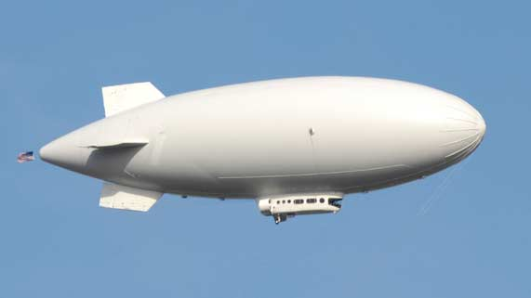
Question 1

Blimps have not been used for widespread air travel since the 1930’s. What is one advantage of bringing blimps back for modern air travel? What is one disadvantage of using blimps?

Type your answer here.

Question 2

Would a scuba diver descend faster in saltwater or freshwater? Explain your answer.

Type your answer here.

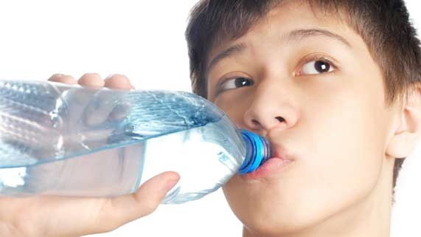
Question 3

In terms of fluid transportation, why is it so important for people to drink eight glasses of water everyday?

Type your answer here.

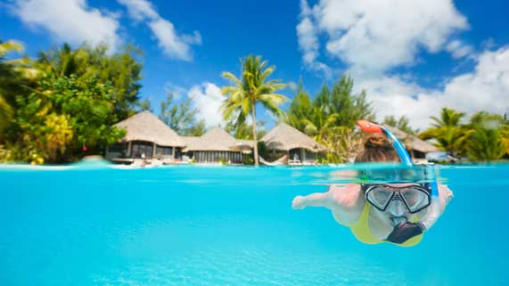
Question 4

Snorkelers use an open breathing tube and a diving mask to see underwater. Why do snorkelers not worry about getting decompression sickness, like scuba divers do?

Type your answer here.

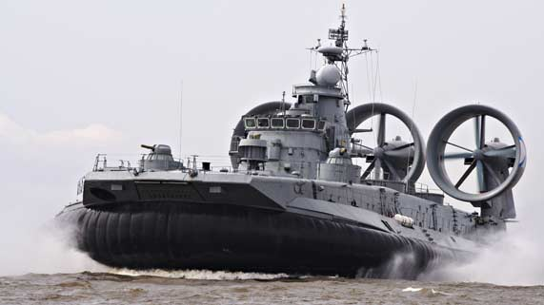
Question 5

Hovercrafts move quickly, but they are not the ideal boat for all situations. Using your knowledge of density and pressure, explain why hovercrafts cannot be used for all boating purposes.

Type your answer here.

Congratulations! You have completed this self-check quiz.

Now it's time to carefully compare your answers to the suggested answers in the online course. When comparing, you should feel free to make changes to your answers or make extra notes.

Don't forget to save the quiz whenever you make changes.

Keep this quiz for study purposes. If you want more feedback, share it with your teacher.

