Science 8
Unit A
Section 4
Self-Check Quiz

Answer all 5 questions in the spaces provided. Think carefully before typing your answers. If you need help, return to the lessons in the online course. Save your quiz when you are done.

Leave your answers in blue; it will be easier for you and your teacher to see them later.


Question 1

Air hockey tables have a fan that forces air upwards through tiny holes on the table. Air hockey pucks have slight edges that trap air under the puck, which makes them float slightly above the surface of the table.

Explain why air hockey pucks float slightly above the surface of an air hockey table.

Type your answer here.

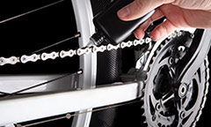
Question 2

Bicycle chains need to be oiled so that the metal gears don’t grind against the metal chain. What is most important factor to consider when selecting a bicycle chain oil: viscosity, density, or solubility? Explain why.

Type your answer here.

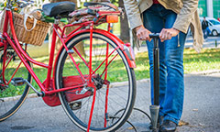
Question 3

To use a hand-held bicycle pump, a woman pushes down on the handle of the pump. This forces air into the bicycle tire. Why is a pump needed to fill bicycle tires with air?

Type your answer here.

Question 4

When a ship moves from an ocean into a river, explain why it sinks slightly in the water.

Type your answer here.

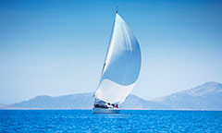
Question 5

When sailboats sail against the wind, the sails have a curved shape. Air moves faster on the outside curve of the sail, and more slowly inside the sail. Explain how the shape of the sails on a sailboat pushes the boat against the wind.

Type your answer here.

Congratulations! You have completed this self-check quiz.

Now it's time to carefully compare your answers to the suggested answers in the online course. When comparing, you should feel free to make changes to your answers or make extra notes.

Don't forget to save the quiz whenever you make changes.

Keep this quiz for study purposes. If you want more feedback, share it with your teacher.

