Science 8
Unit B
Lesson 1
Self-Check Quiz

Answer all 5 questions in the spaces provided. Think carefully before typing your answers. If you need help, return to the lesson in the online course. Save your quiz when you are done.

Leave your answers in blue; it will be easier for you and your teacher to see them later.

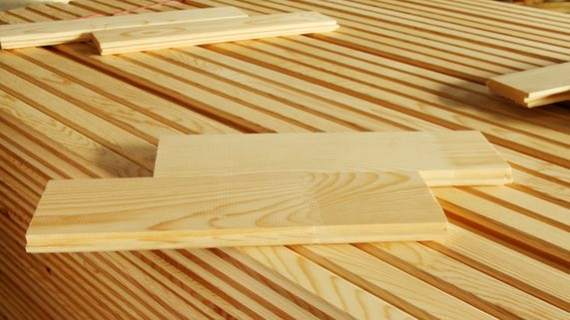
Question 1

Lumber for building is wood made of tiny cells. However, it is no longer alive.

Explain why lumber is not considered to be a living thing.

Type your answer here.

Question 2

Endangered species have very few members still alive on Earth. What characteristics of living things do endangered species struggle to maintain?

Type your answer here.

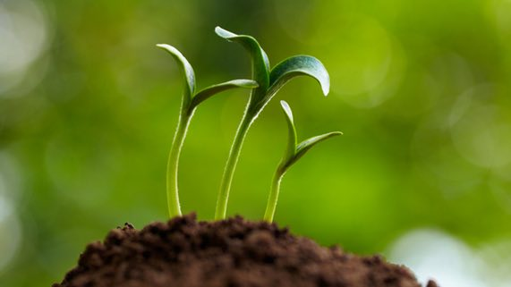
Question 3

On a sunny day, a plant bends towards the light.

How does the movement of a plant demonstrate that it is a living thing? In your answer, try to refer to all six characteristics of living things.

Type your answer here.

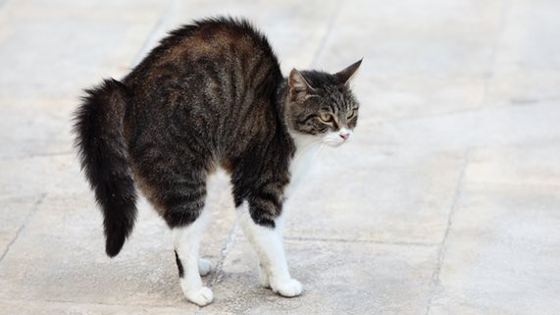
Question 4

What are three adaptations of a pet cat that help it survive?

Type your answer here.

Question 5

All animals obtain their energy from the Sun. Explain this statement.

Type your answer here.

Congratulations! You have completed this self-check quiz.

Now it's time to carefully compare your answers to the suggested answers in the online course. When comparing, you should feel free to make changes to your answers or make extra notes.

Don't forget to save the quiz whenever you make changes.

Keep this quiz for study purposes. If you want more feedback, share it with your teacher.

