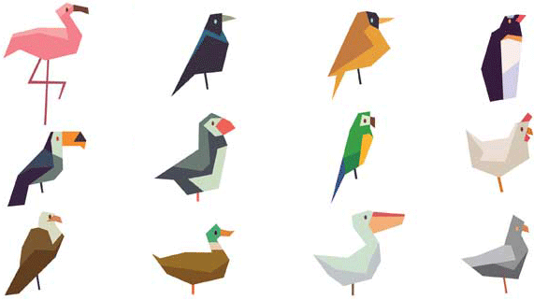
Science 8
Unit B Lesson 2
Try It!
Bird Beaks Simulation

Try this experiment to simulate how a bird’s beak shape affects its ability to gather food.

Materials:

- Clothespin
- Tweezers
- Spoon
- Glass
- Water
- Dry rice
- Dry popcorn kernels
- Glass marbles
- Download of table and questions

Instructions:
Note: When using a “beak”, hold the beak with one hand.
Don’t use your other hand to help put “food” in the beak.
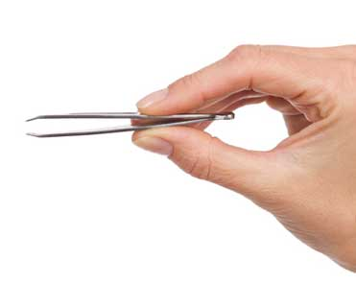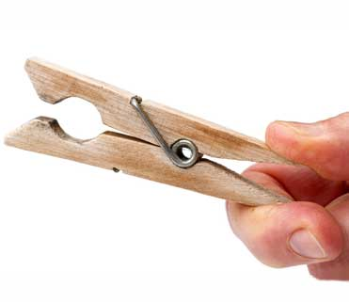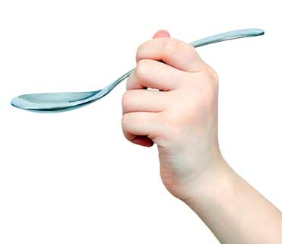

- Spread some popcorn kernels on a flat surface.
- Use each of the three “beaks” (clothespin, tweezers, spoon) to try to pick up the popcorn kernels. Record your observations of using each beak in the table below.
- Spread some rice on a flat surface.
- Use each of the three “beaks” to try to pick up the rice. Record your observations of using each beak in the table below.
- Place several marbles in a glass of water.
- Use each of the three “beaks” to try to pick up the marbles. Record your observations of using each beak in the table on the next page.

Observations:

 | Beaks
 | Tweezers | Clothespin | Spoon
Popcorn
Rice
Marbles

Questions:

Think about the following questions very carefully, then type or write your answers. Once you have your answers, click on the questions in the online course for feedback.

- Which “beak” in the experiment was best adapted for picking up popcorn kernels? Why?
- Which “beak” in the experiment was best adapted for picking up rice? Why?
- Which “beak” in the experiment was best adapted for picking up marbles? Why?
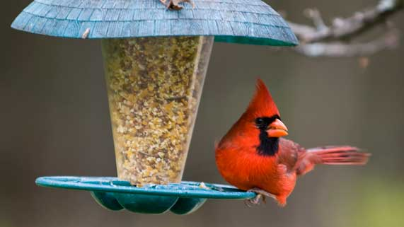
- Cardinals eat seeds. How is the structure of a cardinal’s beak adapted to eat seeds? Which “beak” in the experiment is most similar to a cardinal beak?

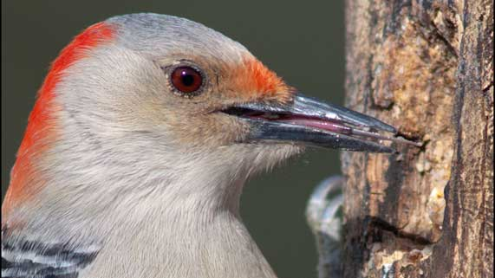
- Woodpeckers eat tiny insects. How is the structure of a woodpecker’s beak adapted to eat tiny insects? Which “beak” in the experiment is most similar to a woodpecker beak?

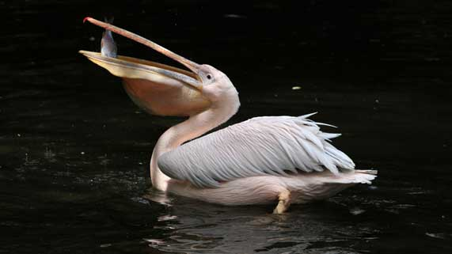
- Pelicans eat fish. How is the structure of a pelican’s beak adapted to eat fish? Which “beak” in the experiment is most similar to a pelican beak?

