Science 8
Unit B
Lesson 2
Self-Check Quiz

Answer all 5 questions in the spaces provided. Think carefully before typing your answers. If you need help, return to the lesson in the online course. Save your quiz when you are done.

Leave your answers in blue; it will be easier for you and your teacher to see them later.

Question 1

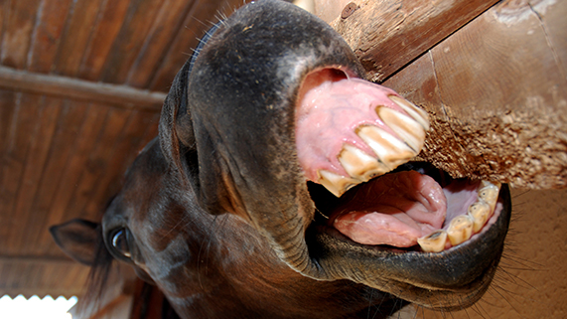
Horses have wide flat teeth.
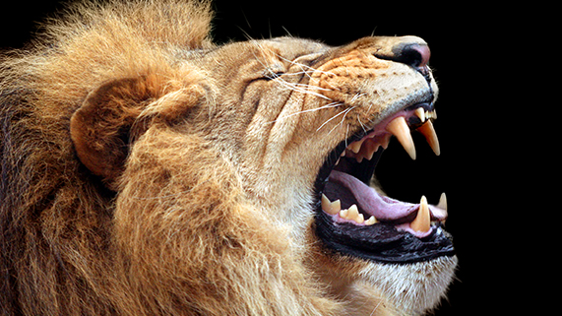
Lions have long pointed teeth.

How are the tooth structures of horses and lions adapted for each animal’s food source?

Type your answer here.

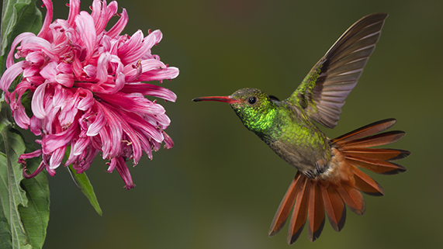
Question 2

Hummingbirds eat flower nectar and insects.

Explain how a hummingbird’s beak structure is adapted for its food-gathering function.

Type your answer here.

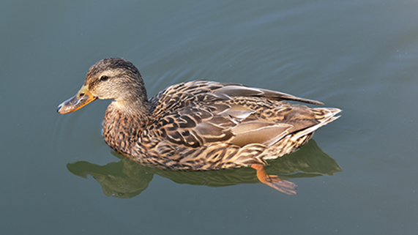
Question 3

Frogs and ducks have webbed feet.

Explain why webbed feet are a useful adaptation for some animals.

Type your answer here.

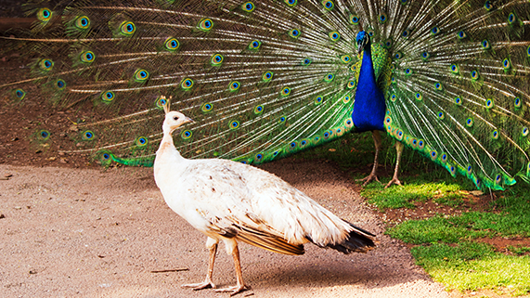
Question 4

Male peacocks have brightly coloured feathers, while female peacocks have brown feathers. How are these feather colours a helpful structure for the function of reproduction, for both male and female peacocks?

Type your answer here.

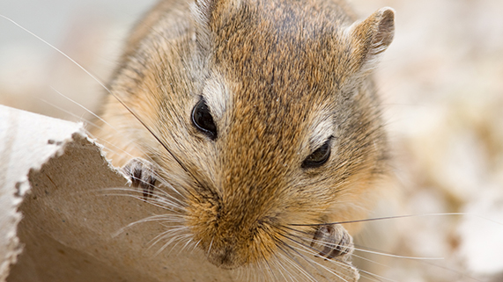
Question 5

Many animals have whiskers on their face. Animals can feel in their skin when their whiskers move, even very tiny movements of the whiskers.

What survival function do whiskers have?

Type your answer here.

Congratulations! You have completed this self-check quiz.

Now it's time to carefully compare your answers to the suggested answers in the online course. When comparing, you should feel free to make changes to your answers or make extra notes.

Don't forget to save the quiz whenever you make changes.

Keep this quiz for study purposes. If you want more feedback, share it with your teacher.

