Science 8
Unit B
Section 1
Self-Check Quiz

Answer all 5 questions in the spaces provided. Think carefully before typing your answers. If you need help, return to the lesson in the online course. Save your quiz when you are done.

Leave your answers in blue; it will be easier for you and your teacher to see them later.

Question 1

What are some characteristics that viruses have, that might make people think that they are alive?

Type your answer here.

Question 2

Why do most scientists consider viruses to be non-living particles?

Type your answer here.

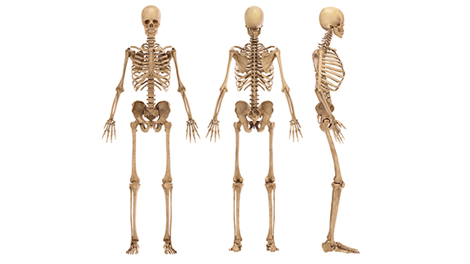
Question 3

What are two functions that bones perform in the human body?

Type your answer here.

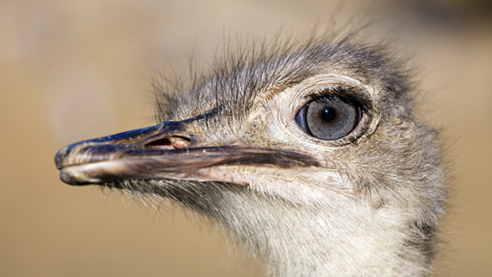
Question 4

Ostriches have massive eyes that are 5 cm wide.

How is the structure of an ostrich’s eyes adapted to help it survive?

Type your answer here.

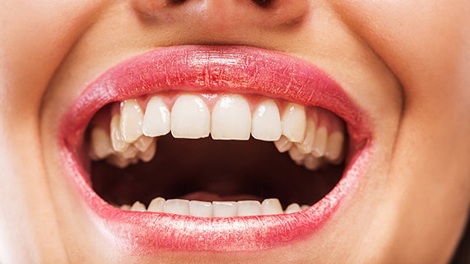
Question 5

Humans have large flat teeth at back of the mouth and sharp pointed teeth at the front of the mouth.

How are human teeth adapted for eating?

Type your answer here.

Congratulations! You have completed this self-check quiz.

Now it's time to carefully compare your answers to the suggested answers in the online course. When comparing, you should feel free to make changes to your answers or make extra notes.

Don't forget to save the quiz whenever you make changes.

Keep this quiz for study purposes. If you want more feedback, share it with your teacher.

