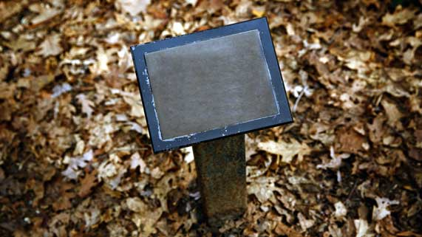
Science 8
Unit B, Section 1
Project
Animal Adaptations Interpretive Sign

The following project is to be submitted to your teacher for marking. Read the project and the method very carefully. Be sure to read the rubric because it provides the expectations for this project.

Situation

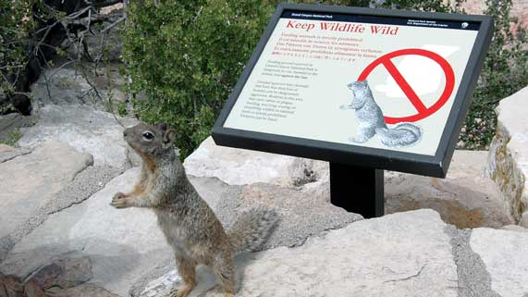
Provincial parks in Alberta protect and preserve natural habitats and wildlife. Albertans enjoy spending time in provincial parks. The Alberta government’s Parks and Environment department designs, produces, and places interpretive signs along walking paths in provincial parks. Outdoor interpretive signs are a good way to teach people about different animals native to Alberta.

The Parks and Environment department wants to get input from youth like you as they make some new park interpretive signs. Can you design an interpretive sign for an Alberta animal?

Project Task

- Choose one of the following animals that are native to Alberta:

- Prairie rattlesnake
- Wolverine
- Badger
- Porcupine
- Wapiti elk
- Bighorn sheep
- Beaver
- Burrowing owl
- Gray jay

If you would like to choose a different Alberta animal, check with your teacher first.

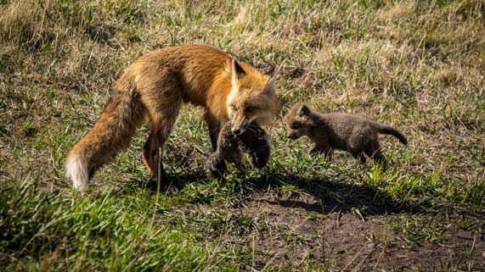
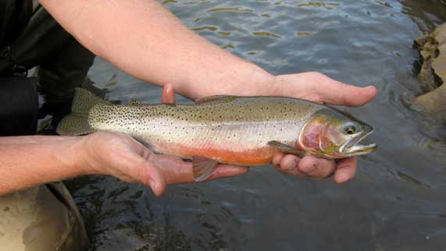

- Research your chosen animal in detail. You can use the Internet or books to carry out your research.

As you research your chosen animal, ask yourself these questions:

- What are the six characteristics of living things and how does my animal show these characteristics? (Lesson B1)
- How do the structures of my animal’s body help it carry out specific tasks, or functions? (Lesson B2)
- What organ systems does my animal have in its body? (Lesson B3)

- Design a provincial park interpretive sign about your animal.

- The interpretive sign should be easy for both children and adults to understand.
- The sign should include pictures as well as written information. Search online for “Examples of interpretive signs” if you are not sure what they look like.

How

Choose the way you would like to design your interpretive sign. Here are some ideas from which you can choose:

- Draw a sign on paper with pencil, paper, and coloured pencils.
- Design a sign in a computer drawing program such as Adobe Photoshop or Gimp.
- Build an interpretive sign using wood or plastic.
- Use other creative ideas, but check with your teacher first!

Requirements

You must clearly communicate the following information in your interpretive sign:

- How does your chosen animal show the six characteristics of living things? Explain in detail how your animal specifically expresses these characteristics.
- Explain in detail three unique structures in your animal’s body that help it carry out specific tasks, or functions, to stay alive.
- Explain in detail two organ systems in your animal’s body. How do these organ systems help the animal stay alive?

Rubric

A rubric explains how your work will be evaluated. It explains clearly all the aspects you must include in your project. Read it very carefully before you start your work.

Animal Adaptations Interpretive Sign
20 marks

CRITERIA | PERFORMANCE
CRITERIA |  | NOT OK | OK | GOOD | EXCELLENT
CRITERIA | Not Submitted  0 marks | Does not  meet criteria  1 mark | Minimally  meets criteria  2 marks | Fully  meets criteria  3 marks | Exceeds  criteria  4 marks
Six (6) characteristics of living things connected to the animal | Not  Submitted | No characteristics of living things connected to animal; details lacking | 1 to 3 characteristics of living things connected to animal; details lacking | 4 or 5 characteristics of living things connected to animal; some supporting details | 6 characteristics of living things connected to animal; many supporting details
Three (3) animal structures connected to their function | Not  Submitted | No animal structures connected to function; details lacking | 1 animal structure connected to function; details lacking | 2 animal structures connected to function; some supporting details | 3 animal structures connected to function; many supporting details
Two (2)  animal organ systems listed and explained | Not  Submitted | No animal organ systems listed or explained; details lacking | 1 animal system listed but not explained; details lacking | 2 animal systems listed and explained; some supporting details | 2 animal systems listed and explained; many supporting details
Creativity | Not  Submitted | Interpretive sign is very simple and lacks imagination | Interpretive sign is very simple but shows some imagination | Interpretive sign has a few details and shows some imagination | Interpretive sign has many details and shows a great deal of imagination
Communication | Not  Submitted | Information is not clearly communicated; details lacking | Information is partly communicated; some details lacking or confusing | Information is partly communicated but descriptions brief | Information is clearly communicated with much detail and clarity

Submitting Your Work

If you do this task as pencil drawing(s) on another piece of paper, you will have to scan your work to submit it.

If you have prepared any other electronic images or documents for this project, you will need to submit them. The same goes for any Internet location where your work is located, you will need to submit the URL so your teacher can view your work.

When you are ready to submit your completed task, return to the Unit B Section 1 Summative Assessment page in your course and click the “Add submission” button at the bottom of the page and follow the directions.

Note that when you submit anything to your teacher, PLEASE INCLUDE YOUR NAME IN THE DOCUMENT TITLE. For example, you might title it something like this:

UnitB_Section1project_Jenny_Smith.doc

