Science 8
Unit B
Lesson 5
Self-Check Quiz

Answer all 5 questions in the spaces provided. Think carefully before typing your answers. If you need help, return to the lesson in the online course. Save your quiz when you are done.

Leave your answers in blue; it will be easier for you and your teacher to see them later.

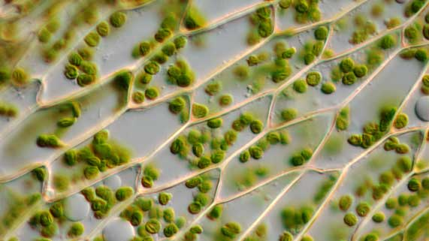
Question 1

Explain why plant cells have chloroplasts while animal cells do not have chloroplasts.

Type your answer here.

Question 2

Why is it difficult to observe cells under a microscope if the slide specimen is thick?

Type your answer here.

Question 3

Humans need insoluble dietary fibre for a healthy digestive system. Explain why humans cannot get insoluble dietary fibre from eating meat.

Type your answer here.

Question 4

Cell walls make plant cells rigid. Why do plant cells need to be more rigid than animal cells?

Type your answer here.

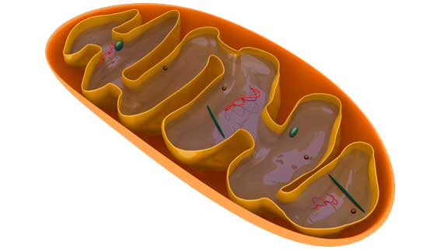
Question 5

Plant cells need mitochondria in addition to chloroplasts. Why do all cells need mitochondria?

Type your answer here.

Congratulations! You have completed this self-check quiz.

Now it's time to carefully compare your answers to the suggested answers in the online course. When comparing, you should feel free to make changes to your answers or make extra notes.

Don't forget to save the quiz whenever you make changes.

Keep this quiz for study purposes. If you want more feedback, share it with your teacher.

