Science 8
Unit B
Lesson 8
Self-Check Quiz

Answer all 5 questions in the spaces provided. Think carefully before typing your answers. If you need help, return to the lesson in the online course. Save your quiz when you are done.

Leave your answers in blue; it will be easier for you and your teacher to see them later.


Question 1

IV (intravenous) lines deliver water directly to a person’s blood vessels. However, IV lines do not contain pure water. IV lines contain a salt solution with a similar concentration to blood.

Why do IV lines need to contain fluid with a similar concentration to blood?

Type your answer here.

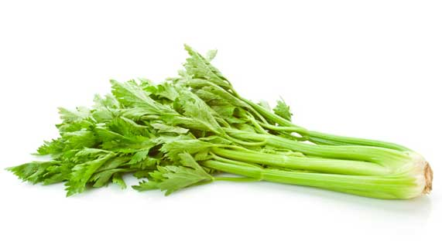
Question 2

Limp celery can be made crisp again by putting it in bowl of cold water.

Explain why water makes limp celery crisp.

Type your answer here.

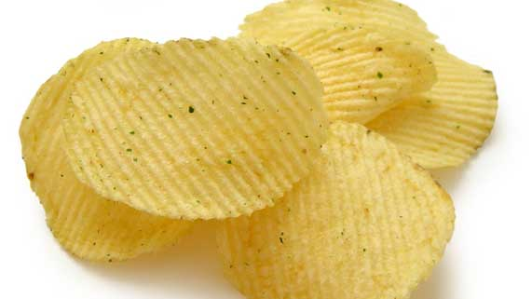
Question 3

Eating a lot of salty foods can result in your body cells containing too much salt. As blood passes by these cells, is water likely to move from the blood to the cells, or from the cells to the blood?

Type your answer here.

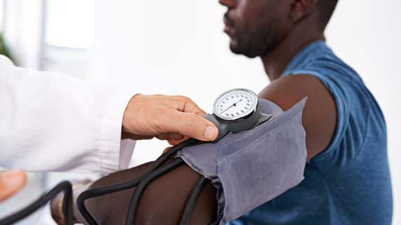
Question 4

High blood pressure puts strain on blood vessels, leading to health problems. Eating too much salt raises person’s blood pressure.

Why does salt increase blood pressure?

Type your answer here.

Question 5

Dehydration occurs when the human body doesn’t contain enough water. Why is dehydration a problem?

Type your answer here.

Congratulations! You have completed this self-check quiz.

Now it's time to carefully compare your answers to the suggested answers in the online course. When comparing, you should feel free to make changes to your answers or make extra notes.

Don't forget to save the quiz whenever you make changes.

Keep this quiz for study purposes. If you want more feedback, share it with your teacher.

