Science 8
Unit B
Lesson 9
Self-Check Quiz

Answer all 5 questions in the spaces provided. Think carefully before typing your answers. If you need help, return to the lesson in the online course. Save your quiz when you are done.

Leave your answers in blue; it will be easier for you and your teacher to see them later.

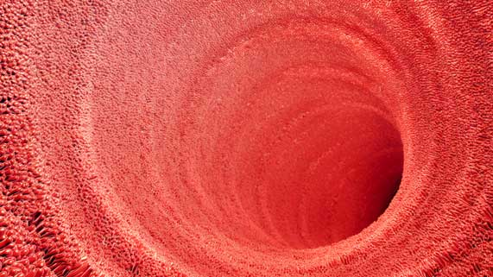
Question 1

People who have celiac disease are severely allergic to gluten. The immune system responds to the presence of gluten by damaging villi in the small intestine.

What symptoms would result from having damaged villi in your small intestine?

Type your answer here.

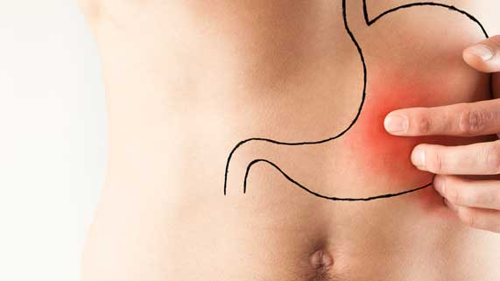
Question 2

A peptic ulcer is a hole in the mucus lining of the stomach.

Why do peptic ulcers cause stomach pain?

Type your answer here.

Question 3

Why do we need to chew our food before swallowing it?

Type your answer here.

Question 4

Explain two places in the digestive system where moving muscle tissue is involved in digestion.

Type your answer here.

Question 5

Explain why both mechanical and chemical digestion are necessary in the digestive system.

Type your answer here.

Congratulations! You have completed this self-check quiz.

Now it's time to carefully compare your answers to the suggested answers in the online course. When comparing, you should feel free to make changes to your answers or make extra notes.

Don't forget to save the quiz whenever you make changes.

Keep this quiz for study purposes. If you want more feedback, share it with your teacher.

