Science 8
Unit B
Lesson 10
Self-Check Quiz

Answer all 5 questions in the spaces provided. Think carefully before typing your answers. If you need help, return to the lesson in the online course. Save your quiz when you are done.

Leave your answers in blue; it will be easier for you and your teacher to see them later.

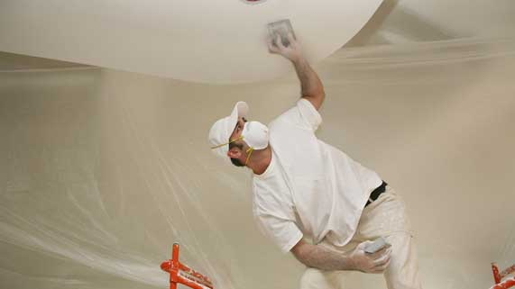
Question 1

A construction worker sanding drywall in a house wears a face mask.

Why is it a good idea to wear a face mask while sanding drywall?

Type your answer here.

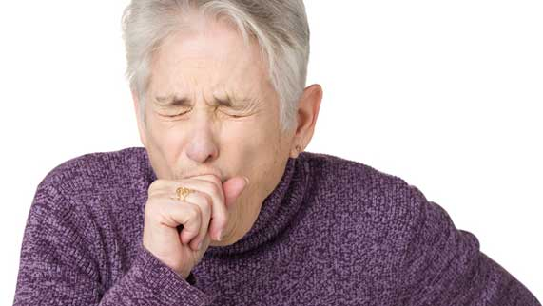
Question 2

The lungs produce extra mucus when a person is sick. Coughing removes mucus from the lungs.

Why does the body cough to remove mucus from the lungs?

Type your answer here.


Question 3

A woman taking singing lessons is told to “breathe with her diaphragm”.

Explain why “breathing with your diaphragm” is helpful for singing.

Type your answer here.

Question 4

Explain four differences between inhalation and exhalation.

Type your answer here.

Question 5

Describe a respiratory health problem that can arise from smoking.

Type your answer here.

Congratulations! You have completed this self-check quiz.

Now it's time to carefully compare your answers to the suggested answers in the online course. When comparing, you should feel free to make changes to your answers or make extra notes.

Don't forget to save the quiz whenever you make changes.

Keep this quiz for study purposes. If you want more feedback, share it with your teacher.

