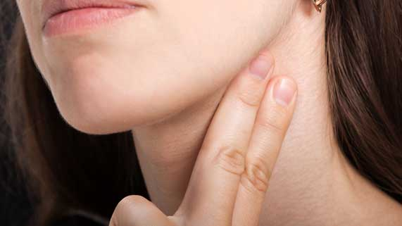
Science 8
Unit B Lesson 11
Try It!
Heart Rate Experiment
Try this experiment to measure your heart rate during different activities.
Materials:
- Timer
Instructions:
- Lie on the floor for 3 minutes.
- Find your pulse on your neck. Place your index finger and middle finger along the front side of your neck until you feel the bumping of your pulse.
- Set the timer for 10 seconds. Start the timer and count how many times you feel your pulse during 10 seconds.
- Record this number in the observations table, under “Beats in 10 seconds”.
- Multiply this number by 6 to calculate and record the number of beats per minute in the observations table.
- Repeat steps 1 to 5. Instead of lying down, do each of the activities listed in the table for 3 minutes. After each activity, allow your heartbeat to return to a normal rate before trying a new activity.
Observations Table:
Activity | Beats in 10 seconds | Beats per minute
Lying down
Sitting
Walking
Running
Jumping Jacks

Question:
Think about the following question very carefully. Then, type or write your answer. When you have your answer, click the question in the online course for feedback.
- Which activities had the highest heart rate and why?

